LEON LEVY EXPEDITION TO ASHKELON
GRID 51 FINAL REPORT 2014
K. Birney
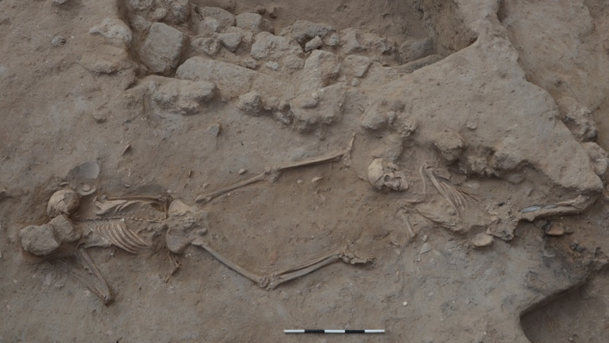
Fig. 1. Victims of Nebuchadnezzar in the 604 Destruction. Photo # 26987

Professional Staff
Jonathan Wiley (Asst. Grid Supervisor)
Mark Lester
Joel Jackson
Emily Shames
Emily Erickson

Season Objectives
The goal for the 2014 season had been to excavate all of the Persian period occupational levels, clarifying the nature of the earliest Persian neighborhood, and going on to expose and fully excavate an area of the 604 B.C. destruction layer beneath. The existence of the 604 destruction layer was first recognized in 2011 after a probe dug from well 74.F11 demonstrated its depth in relation to the Persian material and offered a foretaste of its nature. The outbreak of hostilities between Israel and Hamas shortly after midseason cut excavation short, and as such we fell far short of these goals. Excavations were left in medias res, and as a result there are many areas which remain not fully understood, and many questions to be resolved during the 2015 season. Nonetheless, we did success in getting a sense of the earliest Persian levels, and have uncovered a swath of the 604 destruction which holds the promise of exciting and perhaps terrible things to come.
It should also be noted that in accordance with the wishes of the Parks Authority, the eastern edge of the Grid (rooms in Building 2) was not excavated in 2014. The ashlar doorways and partial sidewalk are being considered as part of a conservation plan and as such our excavations from this point forward will be stepped in by 1m, establishing a new balk just on the eastern edge of the street.

Chronology
There are at present nine known phases within Grid 51, each corresponding to the general chronology below:

Phase I: Islamic (Fatimid-Crusader, 10th-12th c. A.D., 2 subphases)

Phase II: Byzantine (4th-7th c. A.D.)

Phase III: Early Roman (late 2nd B.C. – 1st. A.D.)

Phase IV: Late Hellenistic (ca. 280 – 150 B.C)

Phase V: Late Persian - Early Hellenistic (ca. 350- 290/280 B.C.)

Phase VI: Middle Persian (ca. 400-350 B.C.)

Phase VII A & B: Early Persian ( ca. 500 B.C – ca. 400 B.C.)

Phase VIII: Iron IIC (7th century)

Phase IX*: Pre-7th century

The focus of the 2014 season was on Phases VIII and VII, and results are presented below in chronological order, from earliest to latest. As a complement to this final report, readers are particularly encouraged to read through the Grid 51 reports from 2012-2013 for a complete description of the later Phase VII and early Phase VI levels in the eastern half of Building 1 and the western rooms in Building 2, and to consult the 2011 Grid Report and 2011 51.74 Square report for a discussion of finds from the 604 probe.

Building Plan
Given the general continuity in building plan throughout the Persian and Hellenistic periods in Grid 51, rooms in the insula are referred to by number, beginning with Room 1 in the northwest and ending with Room 17 in the southeast. While there are points at which minor restructuring recurs – the occasional removal of a wall between rooms (between Rooms 5 and 6 during the Late Hellenistic period, for example, or the construction of a partition wall between Rooms 7-8 in Phase VIIa), the general consistency in the building plan and the continuity of function apparent in certain spaces has rendered this a useful system of designation. For reference, the block plan below (not to scale) represents the basic layout of rooms in Building 1.

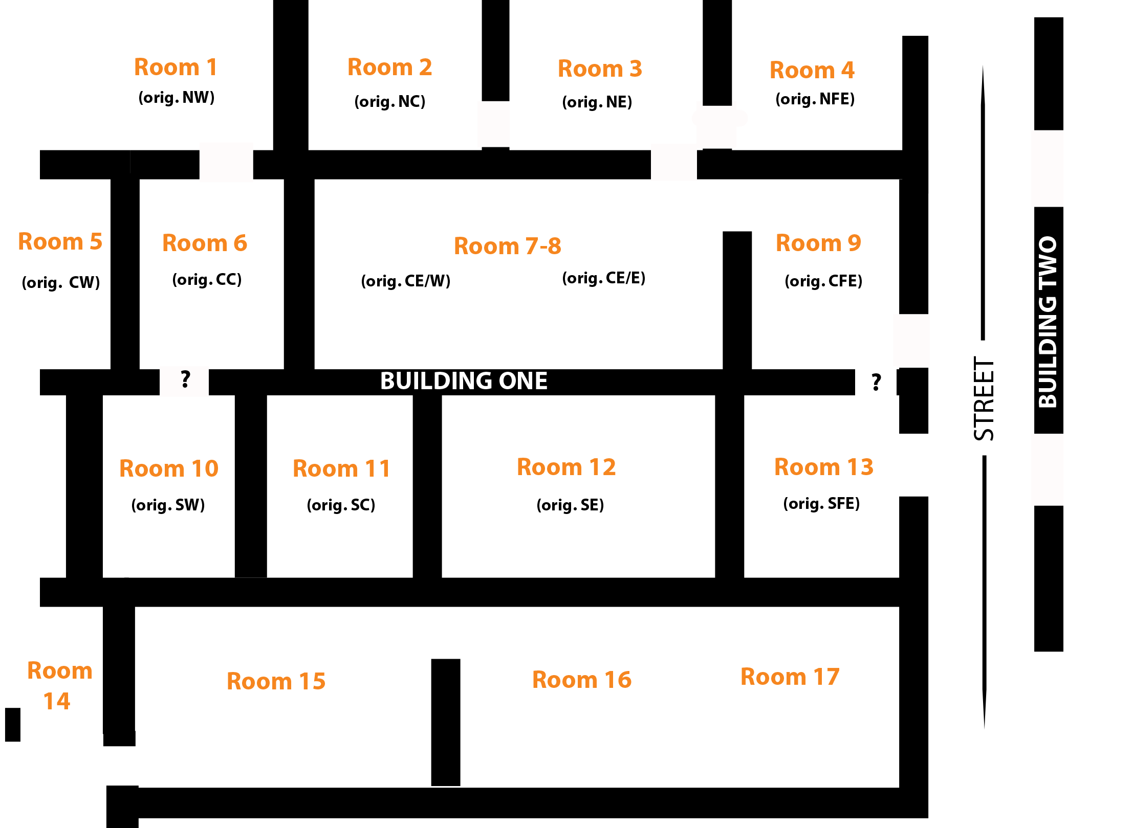

Fig. 3 Room Designations in Insula 1 (walls not to scale)

The 604 Destruction
Even prior to the outbreak of hostilities, it had become necessary to revise our strategy for excavation of the 604 destruction layers in order to ensure (we had hoped) the complete articulation and removal of any areas exposed during the season. As such, we revised our initial plans to expose the full 300 m² of the grid and elected instead to open a more conservative window of roughly 5x3.5m within Square 74, in the areas which had previously been defined Rooms 7-9 in Building 1, in the Persian-Hellenistic levels. The boundaries of this 2014 exposure were between the Persian Phase VII E-W walls 74. U551 (to the south), and wall 74.U571 (to the north). The western limit was the dividing baulk between Square 73 and Square 74; the eastern limit was initially intended to be the 5m baulk at the midpoint of square 74 but was later moved 2m to to the east to provide better stratigraphic sections for micromorphological analysis.
In what had been Room 8, the 604 destruction layer had first been reached in a probe excavated in 2011 in Square 74, by expanding the Islamic well 74.U11 by some 1x1 m to the north and east. (The well probe was positioned in Room 8, and therefore our new work this season was in areas immediately surrounding the probe). The 2011 probe uncovered a layer of abandonment 74.U322 with occupational material 74.U324 (marked by sandy striations ) which including a series of whole vessels and a small hearth. Layer 74.U324 sloped up towards the north and to the east, ranging in elevation from 15.6 to 15.8m (see also the probe east subsidiary section drawing 2011). Above this layer had been some 30 - 40cm uninterrupted fill (74.U306). It was unclear at the time whether this fill was a leveling fill set down by Persian builders in order to construct the new insula in ca 500 B.C., or whether this fill might in fact contain debris – collapsed materials from a second story or roof fall – that was part of the building destroyed in 604 B.C. This season as we returned to the excavation of 604, we worked in conjunction with a team from the Weizmann institute, to determine whether patterns of collapse indistinguishable to the naked eye might be discernable at the microscopic level. According to their experimental protocols, new areas were excavated in 10cm increments which were then laterally sampled for micromorphological study.
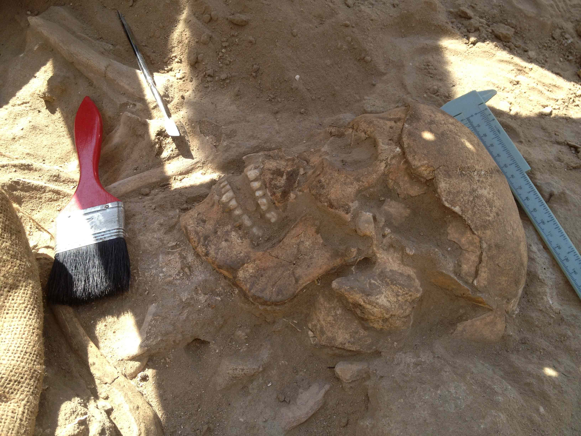
As is so often the case, the pattern suggested by the probe was not broadly applicable. Underneath the Persian period floors in Rooms 8 and 9, rather than encountering 40cm of fill, we encountered very dense stone and hardened mudbricky material (74.U511) a mere 10 – 15 cm below the earliest Phase VII floor. Further excavation demonstrated that this mudbricky material was part of a building which had collapsed onto a floor (not yet numbered), and in which two individuals had been trapped (See Title Page, Fig.1). The northern individual (Burial 219) was lying face up, torso twisted slightly to the right. His legs and the ends of his arms had been cut through by a series of early Persian pits and foundation trenches (74.U581, 74.U545) but a portion of his femur – preserved in the portion in between the pits – was nearby and was burnt to white ash. His pelvis and ribs were likewise pinkened as a result of exposure to the heat, suggesting that he had been trapped underneath burning material. The density of the bricky collapse of 74.U511 above both individuals was probably also due to the fact that the bricks were burnt or burning as they fell; some of these had orange edges as a result of this. The head of Burial 219 was turned to the right, and there was damage to the left temple (see Fig. 2.) which may have been a perimortem injury.
Fig. 2. Skull of Burial 219
The southern individual (Burial 212) was lying facedown, legs akimbo, with his head turned to the left. His right arm was wrapped low around his waist suggesting that it was trapped under his body as the building came down. The ribs had been pushed up and forward by the impact of the falling rubble. No damage to the skull was apparent, nor - apart from the baked debris above him – were there signs of fire or heat damage to the body.
During excavation it was noted that the bones of both individuals were encased in gypsum crystals, of greatest density in the areas around the joints and between the vertebrae. The gypsum appears to have formed as a result of calcium leaching from the bones, coupled with sulfur from the soil or surrounding air – a process which necessitates that the bodies were not buried but rather lay exposed to the elements for some time. At Ashkelon, this phenomenon does not seem to occur on bodies which are properly buried.
Burials 212 and 219 were articulated on the last day of summer fieldwork, but were unable to be removed until September once hostilities had ceased. Although the individuals were covered in the interim, some damage accrued to the skeletons as a result of the prolonged exposure, particularly to Burial 219 which was already fragile due to extreme burning. Despite these challenges, the individuals were safely removed for examination by Marina Faerman of Tel Aviv University. Her preliminary conclusions suggested that both were“effeminate” males, whose jaw shape, femur thickness and size were consistent with masculine measurements, but who exhibited a few feminized traits in addition, notably in the area of the shoulder. Dentition was well preserved and teeth were recovered from both individuals for collagen sampling.
The individuals had fallen onto a beaten earth surface (not yet numbered), which sits at a rough elevation of 16m, and was limited on the west by a wall of small fieldstones 74.U318 (first identified in the 2011 probe) running northwest to southeast. The 604 surface 74.U324 observed in 2011 sloped up from west to east, likely to the west face of this same wall 74.318.
To the west of the well 74.U11 (beneath the area which had been defined as Room 7 in the Persian period) we encountered a second area of 604 destruction. As in the areas to the east, the 604 horizon was considerably shallower than expected.
The absolute limits of the space are not yet fully known, but the rooms are divided by east-west ashlar wall 74.U301 which divides the area into northern and southern halves. A doorway connects the two spaces. The floors 74.U596 (the southern room) and 74.U592 (the northern room) show signs of significant collapse, in the form of ashlar blocks sitting on the floor, and a pile of restorable vessels and substantial portions of disarticulated animal bone). Excavation of these floors was stopped mid-season, and they have been conserved as best as possible with geotech until excavation can be resumed in 2015.

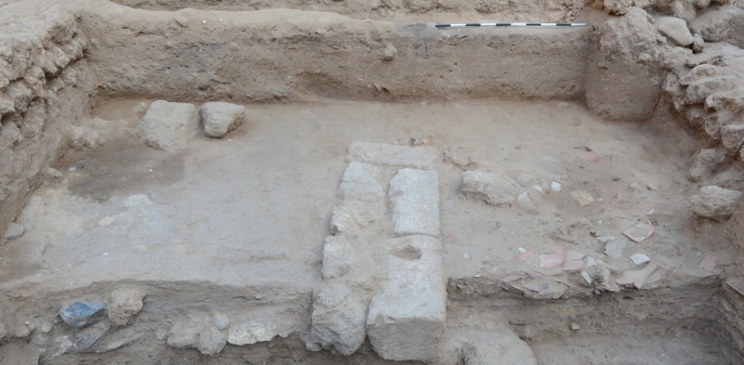
Fig. 3. 604 B.C. floors U596 & U592 (Photo 26989)

Phase VII: The Persian Period (500 – 400/350 B.C)
One of the major goals of the 2014 season had been to come to a full understanding of the nature of the earliest Persian period neighborhood, in the time when Ashkelon was first resettled under Phoenician control, after a hiatus in occupation. While we were unable to achieve this, we were nonetheless able to get a significant look at this earliest phase and to identify significant changes that occur in the neighborhood between Phases VII Early and Late.

Phase VII Early: The Foundation
The builders of Phase VII encountered the ruins of a building burnt in the 604 destruction. Rather than introducing leveling fills, they instead raked the destruction – thick with sherds and debris – just outside of the footprint of the building they planned to build. This trail of debris 74.U591 = 577 is visible rising up to the east underneath the later Persian sidewalk, and sits thickly just against the eastern face of the robber trenches which held the original eastern closing wall of the earliest building (74.U473 and 74.U594). To the east of this wall line, what in Phase VIIB became a north-south line of rooms (Rooms 4, 9, and 13) fronting a north-south street was instead open exterior space in Phase VIIA (74.U541 in the north, 74.U500 in the south). These areas do not appear to have been used for any particular purpose, the industrial needs of the residents apparently being fulfilled in the courtyard to the south of the building, but seem instead to have been generally open space. It is not yet clear whether a street had been founded at this time - sections from later pits cut through street material seem to indicate that there is only a brown fill underneath (75.U169); in any case there certainly does not appear to have been a sidewalk or paving at this stage. This will be conclusively determined in 2015.
Apart from the deviation in the east, the remainder of the building plan appears to have followed the building plan familiar from later phases, though there are still some points which will require further clarification in 2015. The character of the western half of this earliest Phase VII building, for example, is less clear. Phase VII early architecture has not yet been clearly defined in Rooms 1, 5 or 6. Surfaces which are presently understood to be Phase VII Early surfaces were exposed but not excavated in Rooms 5-6. These sandy surfaces (73.289=329) span Rooms 5 and 6, running under the Phase VII Late wall which later divided these rooms, marking a shift in building plan. The sandy layers 73.289=329 sits over what is probably the Phase VII Early surface: an ashy and debris laden surface, which lipped up to walls 73.U316 on the north and 73.U303 to the west. The southern and western parameters are unclear.
Apart from those observable differences, the remainder of Building 1 appears to have been divided into the familiar spaces that provide the architectural template for the subsequent centuries. It appears to have been constructed as an insula, albeit slightly smaller than its successors. Three major east-west walls 73.U328 = 74.U571 (in the north) and 74.U551 (in the middle) and 84.U192 = a not-yet-named wall below 84.U193 formed the backbone of the building. These were connected by a string of north-south walls with stone foundations, some of which remained standing to be reused (73.U316, 73.U296, 73.U290, &74.U512) and others of which were robbed out prior to the larger reconstruction of the building on Phase VII Late (trenches 74.U575, 74.U473, etc.) Despite the fact that they were probably built contemporarily, there does not appear to be uniformity in the style of construction. The walls of many of the Phase VII are solidly grounded in large fieldstones, but there is no pattern placement in the courses, and still other walls are built simply with small to medium sized fieldstones. While mudbrick superstructure appears to have been the norm in Phase VII Late, there are no clear signs that it was employed in the early insula.
In the southern row of rooms in Building 1, as in later phases, Rooms 15-16 were dedicated exterior space. It is as yet unclear whether this courtyard opened directly onto the exterior space to the east, or whether it was closed off by wall 85.U209; this will be sussed out next season. The courtyard was subdivided by a short north-south wall 84.U309, and connected through a doorway to the north with Room 13. The earliest excavated surfaces in this courtyard (83.U165 = 84.U325), particularly in the west, were a series of pavings, alternating with cobblestone, pottery, or crushed glycimeris shell, suggesting a significant need for drainage, and may have been associated with an early version of the hamra-lined installation constructed in this area during Phase VII Late. (It is clear that this later installation was recoated several times and these coatings appear to have sloped up towards the drainage surfaces. Perhaps the later construction cut through an earlier avatar.)
As Phase VII Early surfaces have not been fully excavated throughout the building, it is somewhat premature to comment on the character of the occupation. We note only that the presence of small hearths in Rooms 3 and 12 may indicate small kitchen spaces, different in character from the shared courtyard cooking areas of Phases VI and V.

Phase VII Late: The Expansion
The insula was rebuilt, or at least refurbished, in Phase VII Late. These changes included the widening of at least one of the major spine walls (73.U301) by adding an additional course to the width of the foundation, and then building up a mudbrick superstructure above it (74.U375=73.201), resulting in a wall some 75cm thick. Phase VII Early walls 73.U316 and 73.303 received the same treatment, widened for the construction of 73.213 (above the former) and 73.237 + 225 (above the latter). In addition, buttressing walls were added to the western face of wall 74.U294 in Room 1. On the east, the insula was expanded through the construction of walls (from south to north) 85.U101, 74.U404=74.U123, 74.U509, and a wall robbed by 74.U233. This created rooms 4, 9, 13, and 17. This expansion occurred together with the construction of a curbed sidewalk (75.U165 = 74.U535) and the founding of a street (75.U166), through the center of which a new drain channel was cut (not yet named). The widening of the walls itself may suggest the construction of a second story for the first time. Likewise the ashlar curbing, which is surprisingly substantial for a simple walkway, may have supported pillars holding up an overhanging second story. There are some circular wear patterns on the sidewalk ashlars that might support this hypothesis.
The courtyard 83.U137 = 84.U254=84.U248 maintained its industrial function in Phase VII Late, although with a variety of different installations, resulting in a complicated and chaotic accumulation of materials. At least one tabun (83.U158) was in use in the center of the courtyard for a time. A substantial stone-lined drainage feature – perhaps associated again with the hamra installation 83.U144 was - constructed through the center of the space, north of the tabun. Near the end of Phase VII Late, a row of sunken vessel installations (84.U272; 84.U233; 84.U284; 84.U291) were set down throughout the courtyard. Glycimeris shells and fish remains occurred throughout, raising the possibility that garum production or processing of shellfish may have been at the center of these activities.
Within the insula, the objects recovered from the interior rooms reveal little about the specific uses of space. However, the nature of the material recovered from the insulae during Phase VII Late is of a piece with the types of objects recovered in previous seasons, all of which underscore the cosmopolitan and connected nature of the city at this time. Phoenician connections are evident not only in the items of
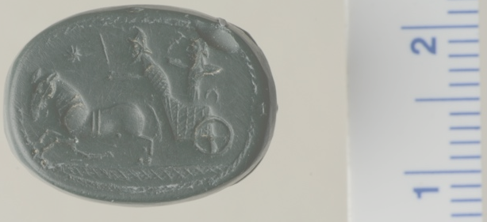
personal adornment and luxury items, such as Greco-Phoenician scarabs (MC 69442) and Phoenician plaque of a female figure in Egyptianizing headdress (MC 74088). Egyptian trinkets, including a jasper scarab (MC 68487), and two udjat eyes (MC 69227 and 69215) can be added to the frit amulets of Bastet and Taweret excavated in 2013, along with a small collection of udjat amulets recovered in 2012-2013. To this international collection we can also add a rich assemblage of Attic ware, including Black Figure (RP 13995), Attic Red Figure (RP 13827), stamped Attic black glaze (RP 14001, 14062, 14135), and lekythoi (RP 14074).
Fig. 4 Greco-Phoenician scarab MC 64992 (Photo # 26609)

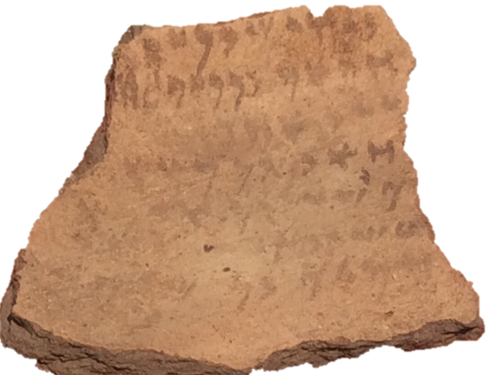
Perhaps most spectacular among the finds – although it is residual – was an eight line ostrakon written in late 6th century cursive script, recovered from within the mudbricks of 74.U211. It presents a list of names, among them Ahimelek, a figure who also appears in a name list discovered in the 604 debris in Grid 50 (Ashkelon Inscription 1.13)

Phase VII summary
Phase VII marks the founding and floruit of Ashkelon as Phoenician marketplace. The depth and density of occupation in Phase VII makes it clear that this phase continued for a significant duration of time. As a gauge, we note that the occupational buildup in the courtyard (Rms 15-17) of Building 1 for this phase was over 60cm deep, and the earliest laminations have not yet been reached. All this is while using the same essential building plan and walls. Phase VII likely represents many generations of occupation, perhaps a century or more, until the neighborhood was fundamentally altered in the early – mid 4th century through the construction of the Phase VI mudbrick floored building. In Phase VI, the broad courtyard which spanned nearly the entire visible width of Building 1 was reduced to the space of Rooms 15-16. An alleyway was added, providing direct access from the street to this courtyard, and the exterior space shifted away from industrial production to a residential cooking space. (For full discussion of the courtyard use in Phases VI and V see Grid Report from 2012). Together with the cessation of industry, we see a reduction in the quality and quantity of luxury objects which seems to be paralleled across the south tell.
Fig. 5 Phoenician ostrakon from 74.U211

Summary
Despite the abbreviated season, we made some significant headway in reconstructin the earliest design of the Phoenician insula of Phase VII Early and the changes the neighborhood went – both in construction and in the quality of its contents - in the shift to Phase VII Late. We do not yet have enough data to be able to identify the date of the transition between Phase VII Early and Late. In the absence of coin data, and given the general continuity in plainware forms throughout the early Persian period, it seems likely that we will have to rely upon the Attic imports recovered from these levels in order to posit a break. There is still much work to be done in refining our understanding of these important transitional levels, and the nature of the city’s first reoccupation after the 604 break.

Thanks are due to directors Larry Stager and Daniel Master for the continuing opportunity to participate in the new phase of the Ashkelon Expedition.

