LEON LEVY EXPEDITION TO ASHKELON
GRID 51 FINAL REPORT 2013
K. Birney

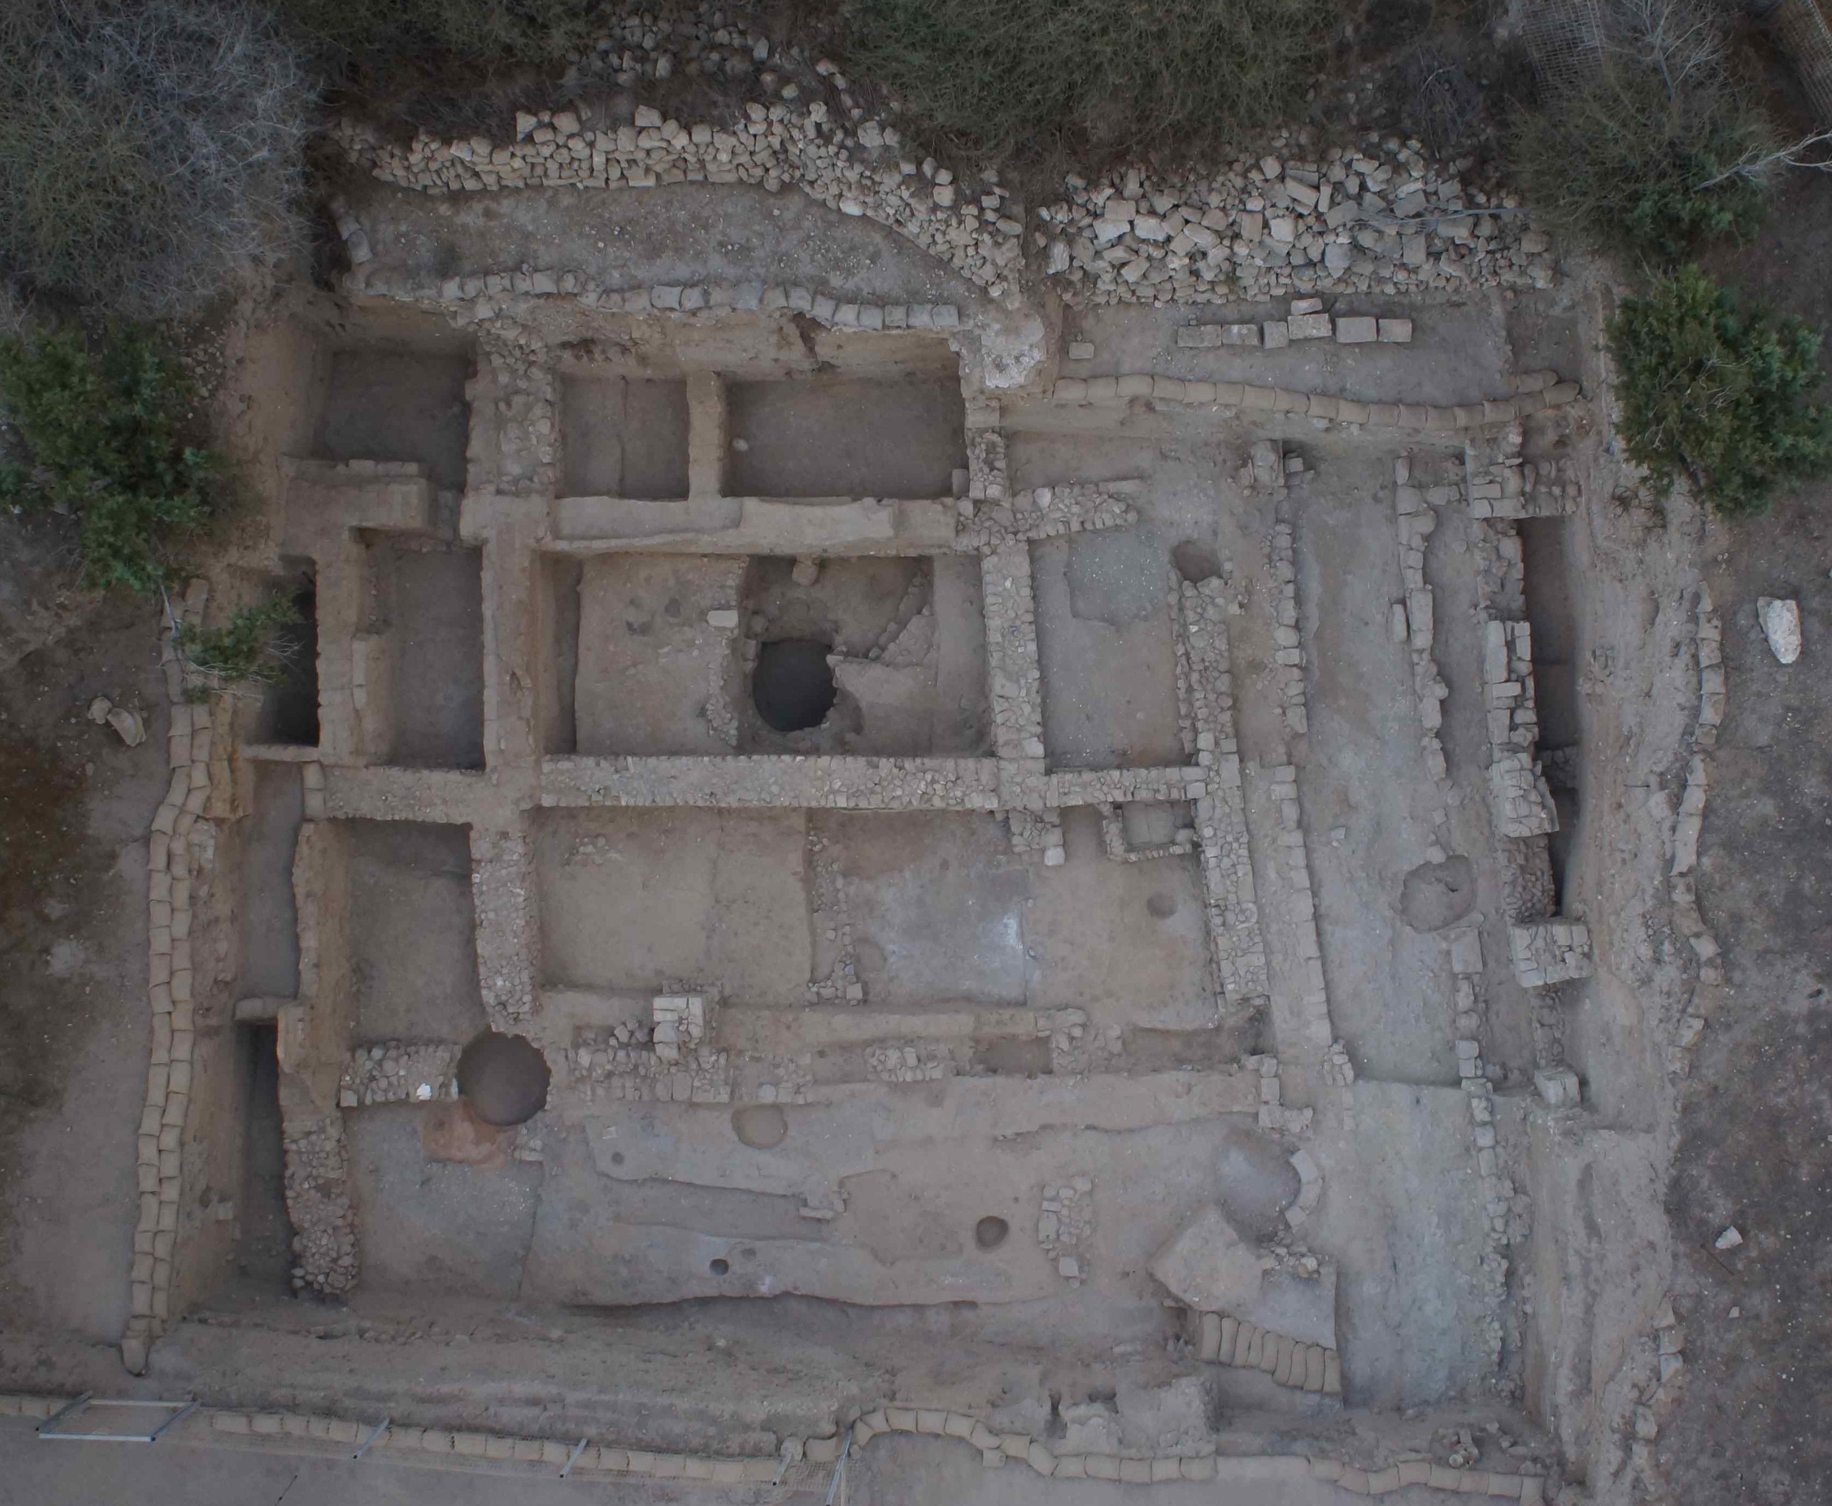
Fig. 1 Grid 51 Overview at the conclusion of the 2013 Season (Photo # A13_26129)

Professional Staff Grid 51 Volunteer Staff
Ben Conner Annikka Bouwsma Christian Nicholson
Sara Hoffman Jennifer Bradley Miranda Peeples
Elise Jakoby Ray ‘Ax’ Dillingham Alaa Qusafsa
Sarah Van der Vorst Trent Dutton Marina Rothberg
Laura Wright Emily Erickson Hannah Roughton
Iced Aroma Shlomit Heering Elias Schwam
Alec Jolicoeur Emily Shames
Jasper Kubasek Stephen Sharpe
Rosie Kelly Kathryn Steely
Nichole Moos Kassandra Williams

Introduction
Grid 51 began as a 100 m² excavation area spanning the eastern half of Square 73 and the western half of Square 74. In 2010, the Grid was expanded 10m to the east and 5m south to create a field of 300 square meters, and the newly opened areas were the focus of our work in the three subsequent seasons. The goal for the 2013 season was finally to bring the upper and lower areas of Grid 51 fully into phase with one another and to excavate the earliest Persian period occupation within the neighborhood (Phase VII Early). These objectives were largely met, as both buildings and the dividing street are now fully in Phase VII. Due to something of an embarrassment of riches in Phase VI and Phase VII Late occupational material we did not fully remove the earliest Phase VII horizon, but sit poised to do so within the first two weeks of 2014. Six weeks of excavation also clarified the relationship between the Early and Middle Persian buildings and suggest a change in the character and quality of the neighborhood between Phases VII and VI.
The 2013 Season results are presented below in chronological order, from earliest to latest. There are at present nine known phases within Grid 51, each corresponding to the general chronology below:

Phase I: Islamic (Fatimid-Crusader, 10th-12th c. A.D., 2 subphases)

Phase II*: Byzantine (4th-7th c. A.D.)

Phase III*: Early Roman (late 2nd B.C. – 1st. A.D.)

Phase IV: Late Hellenistic (ca. 3rd-early 2nd c. B.C)

Phase V: Early Hellenistic (ca. 350-305/290 B.C.)

Phase VI A & B: Late Persian (ca. 400-350 B.C.)

Phase VII A & B: Persian ( ca. 500 B.C – ca. 400 B.C.)

Phase VIII*: Iron IIC (7th century)

Phase IX*: Pre-7th century

* Phases I-III, VIII-IX were not excavated in 2012. Phase VIII will be the focus of the 2014 season

With the exception of the transition between Phases V-IV (tied to coin readings in Grid 57) chronological breaks are based on rough ceramic readings. The Persian and Hellenistic ceramic corpus will be subject to close readings by specialists over the next two years (Persian by Josh Walton; Hellenistic by myself) in preparation for the production of Persian and Hellenistic volumes.
As a complement to the report which follows, readers are encouraged to consult the 2013 Reports for Squares 83-84, 75-85 and 74, and also the Grid final reports from 2010-2011. The latter describes the Phase VI-VII rooms and surfaces from the western half of the building, not excavated in 2013.

Neighborhood Overview
The block plan provided for reference below is composite representation of the Persian – Hellenistic occupation in Insula 1, based on existing walls and robber trenches. While most rooms are consistently structured, it should be noted that there are rooms which were subdivided on occasion, and others which were merged. (The wall between Rooms 10 and 15 was removed for a subphase of VI, etc.

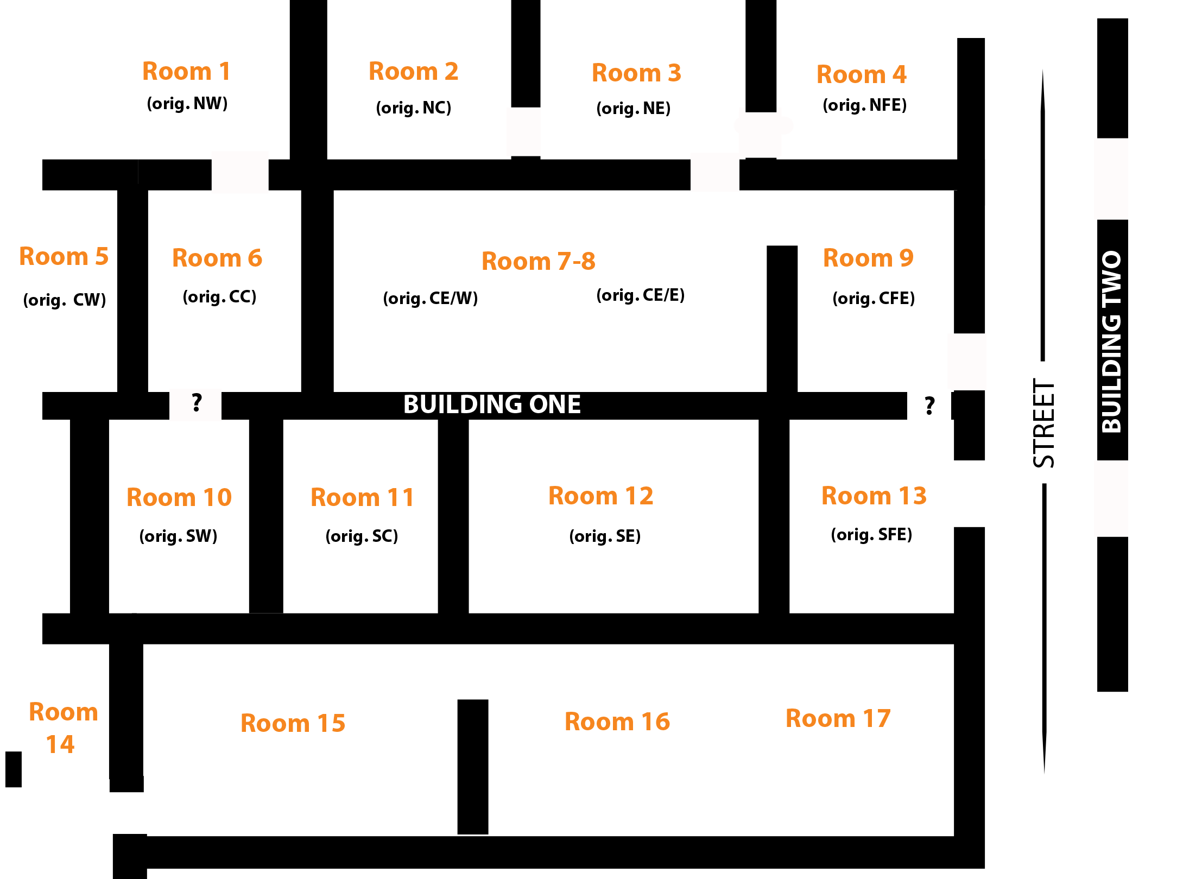

Fig. 2 Room Designations in Insula 1 (walls not to scale)
Doorways shown are those functional in Phase VI.

PHASE 7: ca 500-400 B.C. The Earliest Persian Insula
The 2010 excavation of the probe in Room 8 made clear that Phase VII had two subphases, the earliest associated with a yet lower series of walls. Only a portion of the Phase VII early surfaces have thus far been excavated - Phase VII Early surfaces were excavated in Room 8 (74.U510) and exposed in Room 12 (74.505) - nonetheless the removal of the VII Late horizon has begun to illuminate the architectural plan associated with the earliest Phase VII building. As anticipated, the VII Early plan is in keeping with the later phases of the insula. It is clear that several of the mudbrick walls which have functioned throughout Phases VI-V were originally established at the beginning of Phase VII: the large east-west wall 73.134=74.201=211; the equally wide north-south wall 73.U225. These two walls have formed the basic structure off of which all subsequent interior walls of the west half of the building were built. With the exception of 73.124=74.201/211, the well-founded mudbrick walls do not appear in the eastern half of the building, where stone and ashlar construction seems to have been preferred. For example, there appear to be some breaks in the northern and eastern walls of Room 13 (U442 and U404) showing lower Phase VII walls, slightly offline, with large fieldstone construction; these will be assessed in 2014. In Building 2 there is similarly no sign of lower mudbrick walls. At least two areas of the impressive ashlar façade visible in Phase VII Late (for detailed discussion see below) clearly continue down into VII Early: the ashlar wall 75.U163 and the northern corner formed by the lower courses of 75.U52 and 75.U85.
In Room 8, Phase VII Early beaten earth surface 74. U. 510 (=2010 74.U287) touched the foundation courses of 74.200=211 but ran under the Phase VII Late walls 74.466 to the east; this closing wall is not yet known. TO the south, the surfaces run underneath 74.189=215 and appear to function with a new wall rising just underneath it along the same line. In the southeastern corner of the room was a pit holding an intact Persian cooking pot. RP# 12894. Shell material was dumped in great profusion into a pit in the northern corner of the room. Of particular note from this surface was a partial scarab MC # 67942.

Phase VII Late
The Phase VII Late neighborhood, fully excavated this season, was of a substantially different nature than the Phase VI neighborhood which followed. It is here that we first see the quality inherent in the original construction of the nieighborhood, and the finds are indicative not only of a higher standard of living in this early Persian period, but reflect also the Mediterranean connections typical of a Phoenician coastal city.
The quality of construction is most evident in Building 2, the impressive façade of which was constructed from cut stone ashlars which spanned the length of the wall (rather
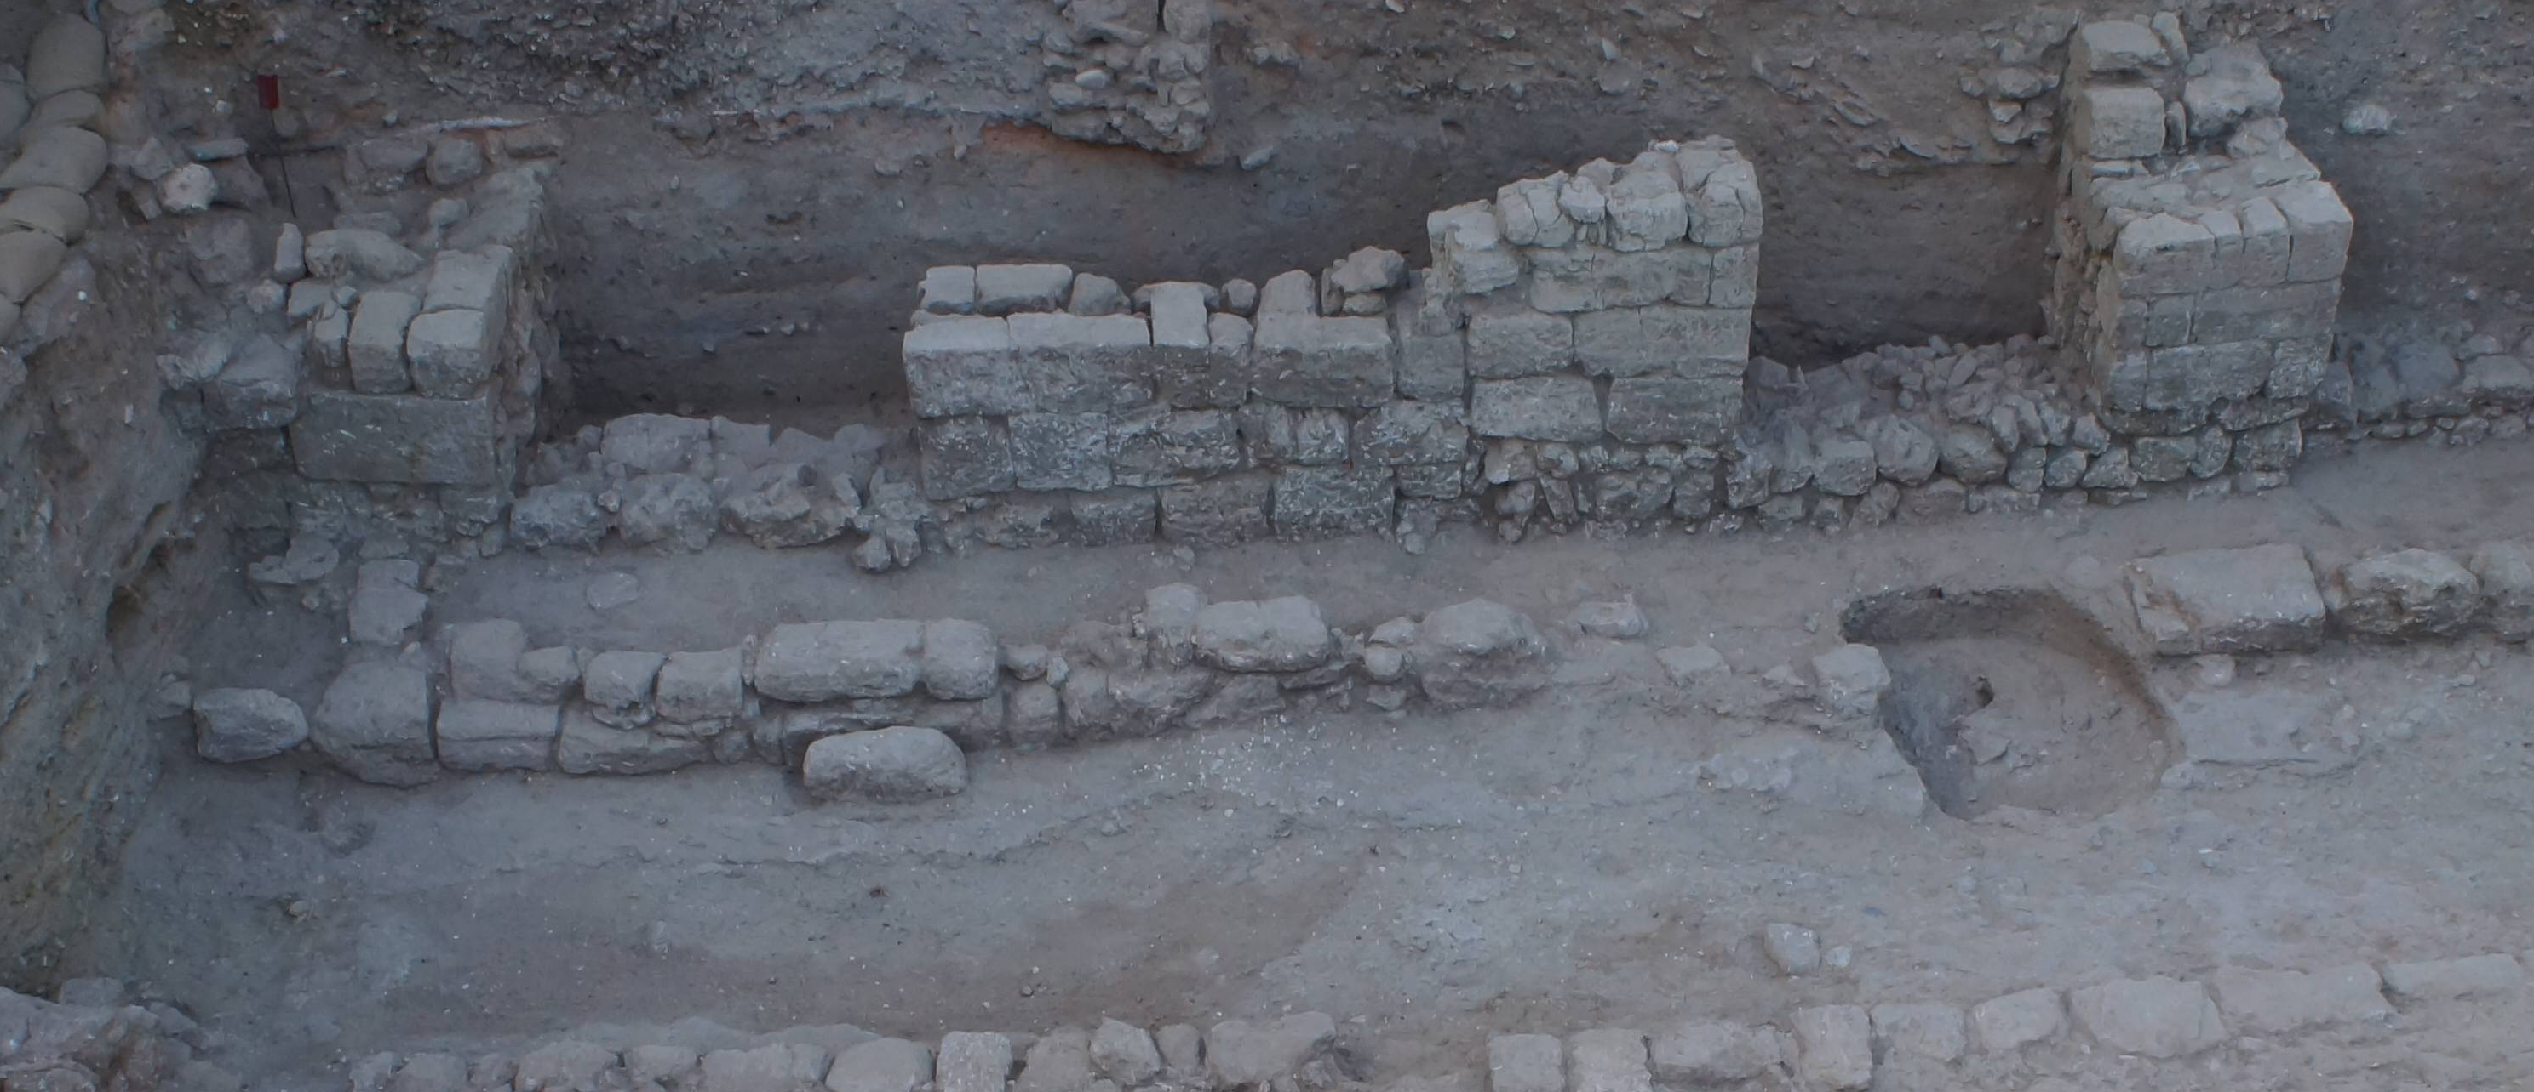
Fig. 3 Exterior walls of Building 2 in Phases VII Late (Photo # A13_26130, view to E)

than being restricted to the doorjambs, as in later Phases). Three doorways, 1.4m in width, were set into these walls and paved with cobblestone thresholds (from north to south: 75.U140, U137, U155)
The earliest Phase VII street 75.U115 was rather narrow in the 5th century, its center spanning only ca. 1.5 m. It was, however, flanked on both sides by curbing of substantial rough-cut fieldstones, at least 2 courses deep. These were set roughly 80cm away from the building edge (75. U153 and 75.U132 on the west side of the street; 75. U143=152=85.U80) on the east, cut into the lowest levels of the street. A small patch of small cobblestones in between the curbing and the edge of Building 1 was all that remained of what had likely been a cobblestone paved sidewalk; apart from these few stones street material accumulated in the gap between the curbing and the buildings on both sides of the street. A slight jog of the curbing on the west side of the street may mark the vestiges of a step down; the shift aligns with the east-west wall line separating Rooms 9 and 13 in Building 1, and likewise with wall 75.U 131 which separates two rooms in Building 2.

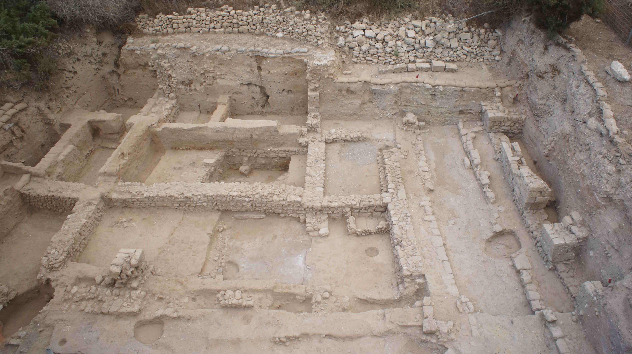
Fig. 4 Grid Overview showing North-South Phase VII street (75.115) and sidewalks 75.154, 75.132 west, 75.143=152 on the east. (Photo # A13_26131, view to N)

This type of irregular paving of roads and sidewalks with compact street material or cobbles is known from Phoenician colonies in the western Mediterranean. Isserlin and du Plat Taylor describe similar features at Sulcis in Sardinia and note other Persian period parallels at Shiqmonah and Tell Abu Hawam. The sidewalks at Tell Abu Hawam are described as “indifferently paved with stone or compressed mud laid on a rubble bedding” (Hamilton 1935: 3). At Ashkelon, these sidewalks would have been quite narrow and convenient only for single-file travel, but prevented pedestrians from stepping into the gully of sandy sewage and street accumulation which ran between the curbs.

Building 1
Excavations in 2011 had already uncovered the Phase VII Late occupation in Rooms in the western half of Building 1. This season the occupational material from this subphase was excavated in the remaining rooms (Rooms 8-9, 12-13, 14-17) with the exception of Rooms 1 and 4, and in Building 2 across the street. Phase VII walls maintained the same general wall lines as those in Phase VI (and indeed in several cases served as the immediate foundations for Phase VI walls). They were, however, generally oriented a few degrees slightly northwest-southeast to the Phase VI wall lines. That such a shift is noticeable not only on the exterior building walls but also the interior/partition walls of the eastern half indicates an overarching building design, rather than half-hazard adjustments made by its occupants. The exterior eastern wall of Building 1 lining the street was constructed using a mix of larger fieldstones with ashlars at intersections and doorjambs.
Phase VII Late surfaces were excavated in the western half of Building 1 in 2011. In 2013 Phase VII Late surfaces were excavated in Rooms 8, 9, 12-14 and the courtyard 15-17. Throughout the building all surfaces – whether interior or exterior - were characterized by shell deposits and debris.
In Room 8, 74.451(=2010 74.284) was excavated along the rooms eastern edge. While a single ashlar on the north side of 74.U282, the western closing wall of the room, indicates a doorway connecting Rooms 7-8, it is unclear whether the doorway to Room 9 was present at this stage. While a number of significant small finds were recovered from this space in 2010 (Scarab MC # 63239, Bastet amulet MC#63252, and two weights MC# 63219, 63262) there were few of note from this eastern end of the room.
In Room 9, sizeable quantities of bronze was recovered from 74.U483, primarily in the form of small fragmented hooks, pins and needles, including a cluster of 14 fused bronze nails (MC # 67588). So copious were the amounts that the greenish tinge from the material leached into the surrounding soil and dyed all faunal material a bright green. It is almost as though the material was a waste dump for metal processing, or a place where scraps were gathered for re-melting. Iron slag MC # 67615 and a whole lamp RP # 12896 were also noted.

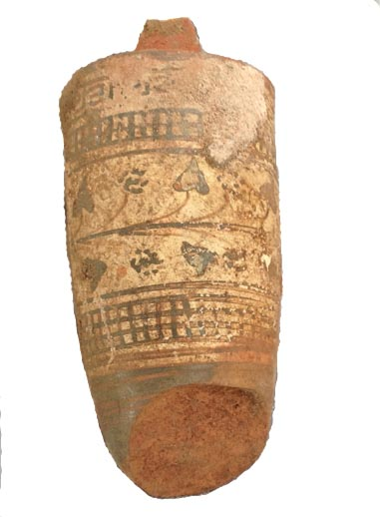
Fig. 5 Lekythos RP# 12758 In Room 13, occupational debris 74.U474 above floor U.498, partially paved with glycimeris shells (distinct from other floors in this phase which were marked by substantial
quantities of shell debris, these appear to have been deliberately laid with the concave side up, perhaps serving as paving for an installation associated with nearby the pit 74.U481/482 immediately to its north. In the north east corner, a stone bin built up against walls U442 and 74.404=75.123, in which was found an Attic Patterned lekythos and an amphoriskos, both popular vessels for the transport of scented oils (from U.496). The lekythos is of the white-ground cylindrical type. On mainland Greece the lekythos is a container for scented oils, and often used in votive or most especially burial rites. Their ritual use is not documented in the Levant (with the exception of a single grave
fact that the vessel is painted only on its front side, with the at Mishmar ha’Emeq (Martin (diss) 320), and they appear instead in domestic contexts. The back was left a blank white ground, suggesting that it is a mass-produced piece purchased for its contents rather than its artistic value (cf Kurtz 1975:131). There are numerous parallels which mirror exactly the same lattice framing and ivy pattern, including one from an Agora deposit; in the southern Levant the pattern lekythos form has been attested in Persian contexts at Gezer, Apollonia, and Tell el-Hesi. The type is stylistically placed in the first half of the 5th century.
Few traces of occupational material were recovered from beaten earth surfaces in Rooms 12 (U.469)and Room 14 (U.148.)

Outdoor Space: The Courtyard
The Phase VII courtyard spanned Rooms 15 and 16, extending nearly 10m in length from 84.U209 in the east to 84.U114 in the west, and was bounded to the north by walls 83.U99 and 84.U192=193. With the exception of the western wall, all other boundaries were heavily and inconsistently robbed with large gaps remaining. As a result, access points to the courtyard cannot be clearly defined. Although a western doorway existed in Phase VI (built using the southern visible extent of wall 83U114 as a threshold), there is no sign that such a doorway existed during Phase VII. An area of mudbrick curbing 84.U279 adjacent to the southern face of 84.U192 may indicate a poorly constructed threshold connecting the courtyard with Room 12 to the north. Excavation in the eastern half of Square 84 will clarify in particular how this space was accessed from the street. (The position of the staircase and exit from the grid has prevented excavation in this area thus far, but will be addressed in 2014.) This larger industrial area showed a substantial accumulation of ashy surfaces associated with a series of superimposed installations, and both the layout of this Phase VII courtyard and its industrial nature continued uninterrupted until the later part Phase VI, when the construction of the mudbrick building repurposed Rooms 16 and 17 into interior domestic space.
The courtyard occupation was marked by continuous construction and use of installations and piles of attendant debris. In the eastern end of the courtyard 83.U137=84.254=84.248 was a broad cut or depression 84.U274 paved with pottery sherds, an installation totally by Phase VI construction above it. Above the sherds were a pile of loomweights (MC #s 67980-1, 67926, 68009, 67926, 67933) and a thin bronze implement, perhaps a shuttle? with an eyehole on one end and a bent flattened tang at the other. (MC # 67894). Although a clear mark of weaving activities, it seems unlikely that this assemblage would have been directly associated with the pottery-paved installation, which seems better suited to facilitate drainage.
In the center of the courtyard were two sunken vessels, 84.233, a store jar on the south and 84. 272 a cooking vessel? (unexcavated 2013) to the north. The two appear to have been separated by some sort of east-west curbing later robbed out by trench 84.U267/8. The southern vessel was surrounded by a heavy area of white ash and burning in excess of 450 degrees F; phytolith and flotation samples were likewise taken but results not yet delivered. On the west side of the courtyard a single square bin or fire pit 83.U144 was cut down through the shelly courtyard 83.134, abutting wall 83.99. Its interior and base was thickly lined with orange hamra (in places up to 10-13 cm thick), and additional lenses of hamra had been smeared up and out of the northern edge of its cut onto the adjacent floor which sloped away to the south. This hamra appears to have been repeatedly re-applied, as courtyard laminations were visible between successive layers of hamra. The coloration of the clay – bright orange – is not characteristic of the more reddish hamra known from Phase VI and VII beaten earth floors elsewhere in the grid, and indicates that it may have been burnt. FTIR of sediment samples from the installation (Sample #s 1287, 1288), however, show that any burning must have been lower than 300 degrees Celsius. No additional material was recovered that might indicate function.

Building 2
While the excavatable portions of two rooms in Building 2 (separated by wall 75.131) only span some total area of 2 square meters, they nonetheless produced some of the season’s most interesting finds. The well-preserved assemblage below came from floors 75.150 (the southern room) and 75.147 (the northern room), and speaks to Ashkelon’s

Excavation of this surface in 2010 had noted shells in the northern edge oo the room and attributed them to a shell-lined mudplaster covering the foundation stones. This plastering did indeed continued to the east into the area excavated in 2013, but the profusion of shells in the adjacent pit is clearly a different feature.
Sardinia: Barreca 1961:38-39; Tell Abu Hawam: Hamilton 1935:3; Shiqmonah Elgavish 1968:13
With the exception of Rooms 1, 4 and 18, to be completed in 2014.
Room 2: 73.U241=74.U268; Room 3: 74.279; Room 5: 73.U267; Room 7: 73.266 (technical horizon); Room 10: 73.U259 , Room 11: 73.255=74.277
The green is distinctively unlike that associated with organic deposits.
A comparable installation was discovered during this horizon in the courtyard to the (Room 17, 84.U262), where shell paving surrounded a pit holding a complete sunken storage jar. Both pits were 45cm in depth.
S.R.. Martin, “’Hellenization’ and Southern Phoenicia: Reconsidering the Impact of Greece Before Alexander” (Berkeley Ph.D. Diss 2007), 321.
Rotroff et al (eds.) Debris from a Public Dining Space in the Athenian Agora; cf. also Martin p.322 n. 81

