LEON LEVY EXPEDITION TO ASHKELON
GRID 51 FINAL REPORT 2012
K. Birney

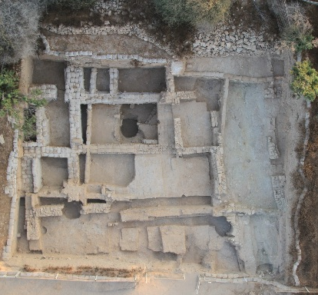
Grid 51 Overview at the Conclusion of the 2012 Season (Photo # 23123)

Grid 51 Professional Staff Grid 51 Volunteer Staff
Dana DePietro Jared Aguayo Sam Roberts
Mark Lester Katherine Cohen Jessica Saba
David Wheatley Ben Conner Jessica Seckler
Alethia Williams Natty Durant Noy Shemesh
Laura Wright Pascal Fiorentino Nicole Siegel
The Waffle Machine Helen Freeman Larissa St. Clair
Hailey Hillsman Desirae Sweet
Christopher Jones Gordon Tucker
Myrna Kenney Kathleen Tucker
Nichole Moos Arakua Wellbeck

GRID 51 FINAL REPORT 2012

Season Objectives
The goal for the 2012 season was to fully excavate the Late Persian/Early Hellenistic (Phase V) material and to bring the upper areas of the Grid (Squares 74 upper, 75, 83, 84, and 85) into phase VI, the late 5th-early 4th century Persian period. This period in Grid 51 is characterized by a well-constructed insula with mudbrick floors. The season’s goal was largely realized. This season the early Hellenistic phase remains (Phase V) were exposed and excavated in the southernmost row of rooms, (Squares 83-84), which now sit poised above the Phase 6 Persian mudbrick-floored building. In Squares 74 and 75, Phase VI surfaces from the aforementioned building were excavated and the street material between Building 1 and 2 was similarly brought into Phase VI. Phase VI mudbrick surfaces were likewise exposed and articulated in two adjacent patches in Square 84.
Despite the appreciable aesthetics of the Phase VI mudbrick flooring, it was the Phase V remains that were in fact the most interesting of the season, and offer the most insight into the occupational history of Insula 1 and the transition from the Persian to the Hellenistic period.

Phasing and Chronology
There are at present ten known phases within Grid 51, which adhere roughly to the chronology below:

Phase I: Islamic (Fatimid-Crusader, 10th-12th c. A.D., 2 subphases)

Phase II: Byzantine (4th-7th c. A.D.)

Phase III: Early Roman (late 2nd B.C. – 1st. A.D.)

Phase IV: Late Hellenistic (ca. 3rd-early 2nd c. B.C)

Phase V: Early Hellenistic (ca. 350-305/290 B.C.)

Phase VI: Late Persian (ca. 400-350 B.C.)

Phase VII*: Persian ( ca. 500 B.C – ca. 400 B.C.)

Phase VIII*: Iron IIC (7th century)

Phase IX*: Pre-7th century

*Phases VII-IX were not excavated in 2012. Phase VII will be the focus of the 2013 season, while Phase VIII and below will be the focus of 2014.

The 2012 Season results are presented below in chronological order, from earliest to latest. Readers are encouraged to consult the final reports from 2008-2010, which present a complementary picture to the Phase IV-VI rooms not excavated in 2012.

The Persian – Hellenistic Insula: Phases VII-IV
These phases presently constitute the major focus of Grid 51. Work over the previous three seasons has revealed a substantial portion of a Persian – Hellenistic neighborhood consisting of two insulae separated by a NW-SE running street, which was laid out parallel to the coastline. As noted in previous reports, the building plan remained essentially consistent throughout some 6 centuries of occupation, reusing the same general wall lines albeit with changes in the placement of doorways and interior walls. In the early phases of excavation we used geographic designations for the rooms (NE, NW, etc.) to describe the activities of each phase. However, as more of the building has been exposed – and given current plans for exposing an additional 5m to the south in the 2013 season, these designations are becoming unwieldy and a different nomenclature is required. For this reason we are turning to a simple numeric designations for each room – illustrated below - beginning with Room 1 in the northwest of Building 1, with numbers increasing towards the east. (See Fig. 2, below.) This mirrors the larger grid pattern of the site of Ashkelon itself and will accommodate the southern expansion without requiring any further changes to the numbering system.
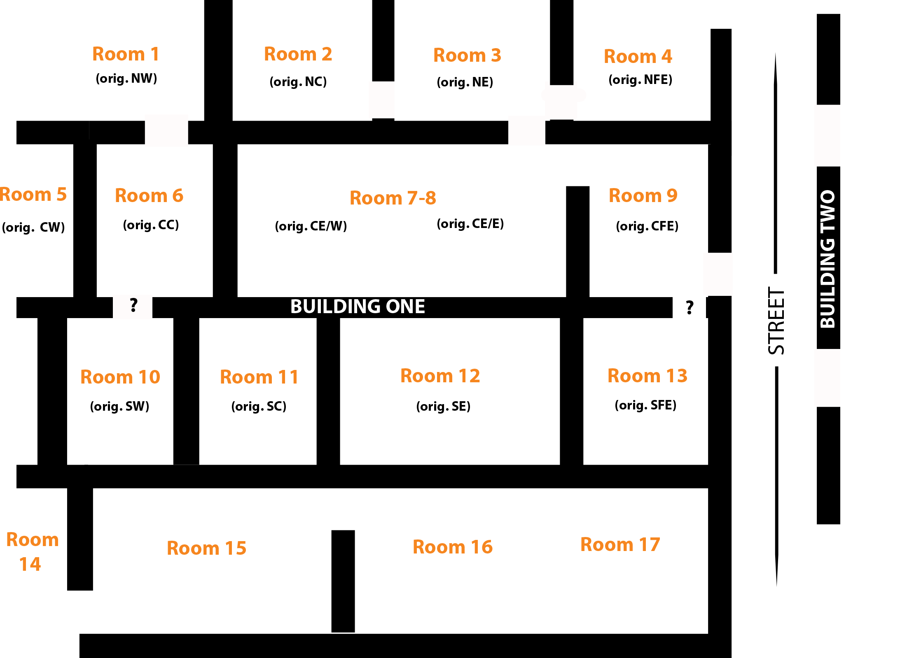

Fig. 2 Room designations in Insulae 1 (not to scale)
Doorways shown are those functional in Phase V (Late Persian)

The block plan above is composite representation of the Persian – Hellenistic occupation in Insula 1, based on existing walls and robber trenches. While most rooms are consistently structured, it should be noted that there are two rooms which were subdivided on occasion. Room 7-8, for example, is separated into two rooms in the earliest Persian Phase VII, but in Phase VI is unified as a single larger room. Likewise Room 12, while a single room in Phases VII-IV, is subdivided in Phase III. The precise division between Rooms 16 and 17 is not yet known due to the substantial robbing of both walls and floors in this area (this space having likely housed something like a subfloor chamber for the Phase IA bathhouse).

PHASE VI: The Persian Mudbrick-Floored Building (ca. 400-350 B.C.)
This season revealed mudbrick floors in the eastern half of rooms previously excavated in 2008: Room 7-8 (initially described in the 2008 reports as the Center-East room) and Room 12 (appears in the 2008 reports as the SW room). In Room 8,the east-west bricks of the equivalent floor 74.U173 were found to continue one row to the east, after which point the pattern ceased and bricks were fit in the remaining space up to 74.U323 in whatever manner possible.
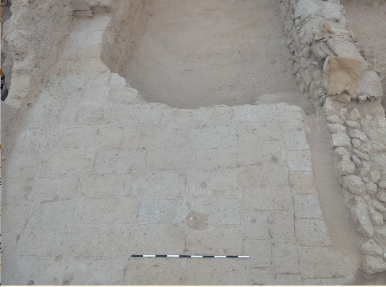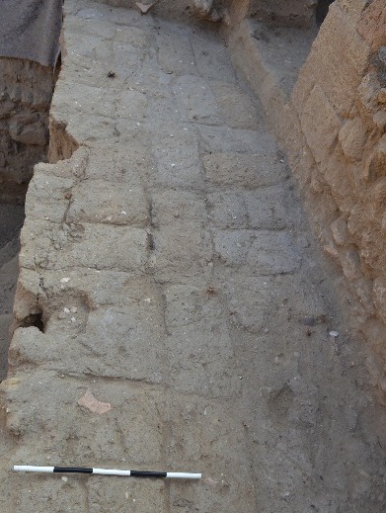

Fig. 3 Phase VI Mudbrick floors 74.U420 in Room 12 (left) and 74. U417 in Room 8 (right ). Photo # 22546

In Room 12, the mudbrick floor 74.U420 (= 74.U190) was seen to continue the north-south brick arrangement of the earlier floor, with well preserved mortar lines up to 4cm in thickness between bricks. The seemingly elegant arrangement of the mudbrick floors of Room 12 stands in stark contrast to its hodgepodge of closing walls, each representing different types of construction. This mix of styles is typical of the more erratic nature of the interior wall construction of the insula in many phases. The Room 12 surface 74.U420 (= 74.U190) was bounded to the north by 74.189=215, a wall with solid field and cobblestone foundations up to seven courses deep. Its western limit, however, was 74.U131, a sloppily constructed mudbrick wall with bricks of shockingly poor quality. Its eastern limit, the wall 74.402 was largely robbed out at the end of the phase by trench 74. U….. Despite this activity the few stones remaining on its northern end abutting wall 74.U403 are small but well-cut ashlars. (The southern closing wall was robbed in the Fatimid period, 74.U265.) The room spanned roughly 5 x 3.3m.
Room 7-8, mostly excavated in 2008, was an even larger room defined in this space by the N-S mudbrick wall 73.U216 to the west, 73.134=74.201 to the north, 74.189=215 to the south and an eastern closing wall (as yet unexcavated) beneath the Phase IV wall 74.U323. The room dimensions were 7 x 3.3m, and it was accessible from doorways to the east (north of 74.U323), and the north, through a doorway (74.U291) in 74.U201, connecting to Room 3. This is a rather large span for an interior room, however there is no indication of any division or additional support structure - either now or from previous seasons of excavation. The mudbrick floors in this space, 74.U173=74.417 continued the horizontal pattern from the western half of the room until the builders ran out of space in proximity to the eastern wall, after which point a mix of orientations were applied.
The occupational debris above the mudbrick floors in both rooms was quite thin, and few finds of note were recovered, certainly nothing to indicate the use of the room. We note here only a single coin MC # recovered from 74.U420 in Room 12, and an unusual chalk game piece from above the floor 74.417, MC# 65841.
In two rooms, Room 9 and Room 13, Phase VI floors were of beaten earth rather than of mudbrick. Subsequent excavation may yet reveal lower Phase VI surfaces in these rooms, however the ceramic horizon marks these surfaces and their subfloor fills as entirely Persian (and therefore not Phase V). The sequence of these surfaces - especially in Room 9, where the doorway connects them – is visible in relation to the neighboring street accumulation and thus provides a narrow phasing window.
In Room 9, the occupational debris 74.U355 was relatively thin but its ending appears to have been somewhat abrupt, with substantial amounts of what appears to have been collapse – stones, collapsed mudbrick and pottery – on the original floor 74.U415. One complete juglet RP# 12339 was recovered from this debris. A socket stone, MC # 65778 likely functioned with the door for the adjacent cobblestone threshold into the street 74.U427. Despite the seemingly poor quality of this beaten earth floor in relation to the mudbrick flooring in contemporary rooms, a number of the small finds from this space stand out in quality. These include three bronze pins, including one fibula MC # 65789, and a piece of ivory inlay MC #66194.
A similar pattern holds in Room 13, immediately adjacent to the south, though a bit lower down the terrace. The surface in this room, 74.U415, was thickly coated with hamra clay, in several applications, leaving the impression of a red plastered surface. A bronze pin MC # 66003, a fragment of worked limestone MC# 65827, a complete Egyptian alabaster/gypsum alabastron MC# 65672 and fragment of an alabaster bowl were found on this floor.
Collectively, while the finds are relatively few, the small materials collected from the Phase VI floors are richer in nature and quality than those that tend to be recovered from later periods. This is especially so in Rooms 9 and 13, despite the poor character of their floors relative to the mudbrick tiles. Perhaps we misjudge the quality of the mudbrick floors; perhaps the bright red hamra floors were more aesthetically pleasing and considered better suited for display to visitors entering the storefront or vestibules of the Insula, while the mudbrick floors were limited to the interior spaces.
The end of Phase VI was marked in all rooms by signs of abandonment and disruption, most clearly seen in Rooms 9 and 13. At Dor, a disruption dating to ca. 350 B.C. is associated with the aftermath of the Phoenician uprising, despite the fact that there was no widespread destruction at the site. It becomes difficult to postulate a political reason for the abandonment we see at this horizon at Ashkelon, most particularly as Phoenician rebellion against the Persians was a Sidonian-led event, and it is unclear that the cities under Tyrian control were affected. (Stern 1995:274). Nonetheless, the break at ca. 350 B.C. remains clear at Ashkelon as well.

PHASE V: The Persian-Hellenistic Transition – Reuse of the Mudbrick Building
This season’s efforts were focused on excavating remaining Phase V surfaces in Building 1, and the contemporary street material in Squares 75 and 85. The exterior spaces in Squares 75 and 85 were only excavated for half of the season in an effort to focus attention on the interior spaces of Building 1. Nevertheless most of the Phase V street was excavated, and we now have our first glimpse of the Persian period drainage system in Square 85.
Phase V is the first period in which Hellenistic pottery appears, and is characterized by the reoccupation of the mudbrick floor building after a short lapse in occupation. Exposure of Phase VI surfaces is marked by signs of abandonment - lenses of sand and clay atop the mudbrick floors (73.L 74.L193 = L173, 74.L150, 74.LNFE, 75.U83) in several rooms. These layers accumulated atop the limited Phase VI occupational debris, suggesting mudbrick melt and exposure, and were followed by shallow leveling fills for the Phase V beaten earth surfaces which followed.
In most rooms of Building 1, Phase V occupation tended to be or poorly preserved, suggesting only a short window of occupation.. The greatest density of occupation was exposed in Room 6 (excavated in 2008-2009) and in Room 12 and the Courtyard Room15 excavated in this season, and with the help of the botanicals recovered from this spaces should do much to illuminate the use of space during this period.

The Interior Spaces: Rooms 12 & 13 and Building 2
In Building 2 the Phase VI walls 75.U52, 75.U85, U.43, U.61 and U.69 were reused in Phase V, and the V street 75.U86 accumulated against them. Our limited information regarding Phase V in Building 2 derives almost entirely from the section, as the Phase IV installations were cut down through whatever patches of Phase V flooring might have been extant just inside the line of the walls. From the 75 East section, however, a thin line of floor, 75.U can be seen sloping down from north to south in a small area of the doorway between 75.U41 and U.61, where it was undisturbed by the later bins. This surface appears at an elevation equivalent with the mudbrick and stone threshold 75.U93 which appears at the midpoint of this sizeable doorway. Laminations of 75.U were traceable in a very small (30cm) area between the top of this threshold and the section. Atop this surface, also visible in section, was a dense area of pottery collapse, perhaps associated with the Phase V destruction or abandonment of the Building (to be discussed below).
In Building 1, Phase V surfaces were excavated in Rooms 12 and 13. In these spaces the Phase VI walls were largely reused with the exception of their shared wall, 74.U402, which was robbed out at the beginning of this Phase for the construction of a more substantial N-S dividing wall, later robbed out by the trench 74.U290. The surface in Room 13 to the east held minimal occupational debris, only slight lenses of clay and ash in small quantities. The paucity of occupational laminations was wholly offset, however, by one magnificent find attributed to this floor, an agate pendant Achaemenid stamp seal MC # 65088, pictured below.

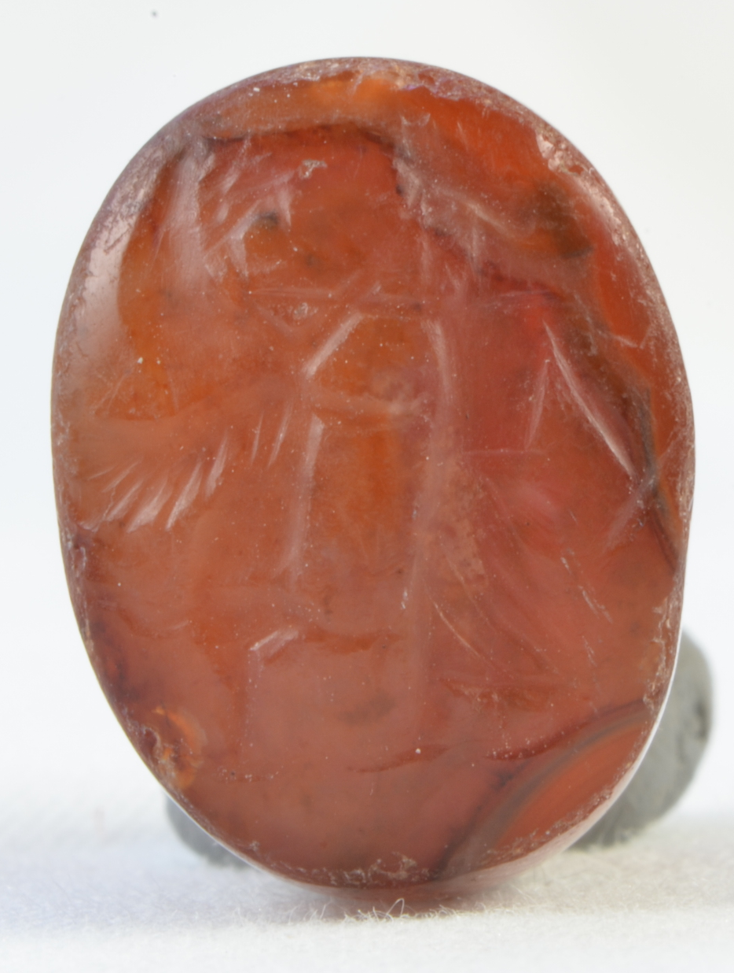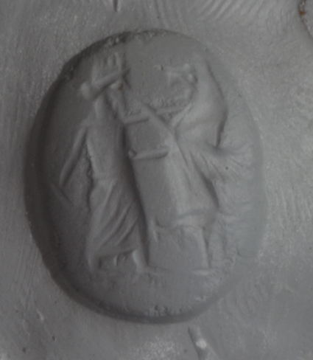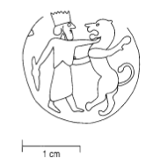
a. b.
Fig 4. (a) Achaemenid Stamp Seal MC# 65088 from 74.U399 and its impression
(Photo # 21416); (b) Persepolis parallel PFS 1428 (Garrison et al. 2001: Pl. 127 b.)

The image is that of a crowned figure in a long, layered robe, stabbing a griffin in the neck with his left hand, holding a weapon or staff down in his right hand behind him. Immediate parallels can be found among the Achaemenid period Persian Fortification seals (e.g. PFS 1428 above), but such iconography is generally typical of Achaemenid seals and is a familiar variant belonging to the rich tradition of “master of animals” seals. Other Persian period comparanda, both exact parallels and those exhibiting slight variations (uncrowned figures, stabbing the beast in the belly rather than the neck, etc.) are known from the Persepolis fortifications as far as west as Sardis and likely beyond.
In Room 12, a dense phytolith-rich surface 74.U392=74.184 spanned the extent of the room, reusing the Phase VI walls, except that it was limited on the east by a newly constructed closing wall (now robbed by 74.U290). The 74 2012 Square report notes some complicating factors to this interpretation, namely the fact that a strip of flooring appears to have been preserved in a thin E-W line that spanned the southern extent of this trench. The other candidates for N-S closing walls to this space must be ruled out: 74.402, the Phase VI wall, was robbed out by trench 74.400 at the end of VI and is covered over by Phase V leveling fills set down prior to the construction of the Phase V floors. The foundation trench of 74.U334, the Phase IV closing wall, was cut from elevations far above the V surfaces on either side. The preservation of the surface in this southern end of the trench may reflect instead the presence of a doorway in this space connecting Rooms 12 and 13. The depth and sharp horizontal line of the robber trench north of this line of floor might best be understood as the robbing of the ashlar jamb.
This surface was thick with white phytoliths. According to phytolith and microarchaeological samples taken from this floor in fall 2011 (from the south subsidiary section), the dense organic material coating this floor is largely cereal chaff mixed with some straw. No installations were recovered from the space. The density of the phytolith accumulation and suggests that this space might have been used for the processing or storage of cereals.

The Exterior Spaces: Street and Courtyard

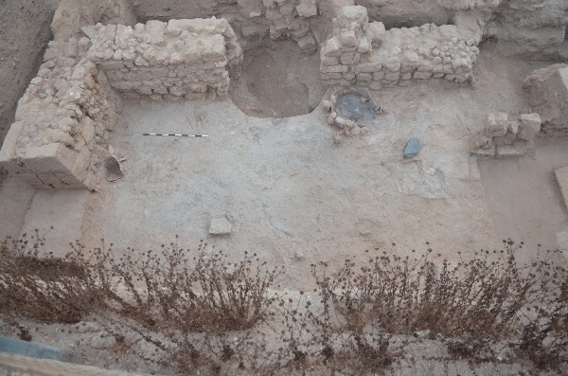
Fig 5. The Phase V courtyard, viewed to the north. (Photo # 22751)

The courtyard (Room 15) was accessible from rooms immediately to the east and west (14 and 16) through doorways built with ashlar jambs. It was delineated by wall 83.U25 to the west, 83.U52=84.U100 on the south, on the east by the robbed wall 84.U18 (robbed out by Fatimid trench 84.U26/27). Its southern boundary is unknown and extends south of the currently excavated area. The original courtyard surface 83.U85=84.U161 was covered by some 20cm of occupational accumulation 83.U65=84.U119. This was most dense in the area of the tabun 84.U152 which had been set against the southern face of the wall 84.U100 near the eastern doorway.

It was here that the concentration of ash was the heaviest, and lensed out towards the north and the east, where the sandy striations more typical of courtyard space appeared. The tabun (Fig. 6) was in use throughout the entire phase and can be seen in section crushed and covered over by the Phase IV courtyard surface 83.57=84.117. Note too the late 4th-early 3rd c. Attic imitation incurved rim bowl lying against it in the photo to the right. To the south, an east-west row of mudbricks 84.U162 served as a bench or narrow working platform.
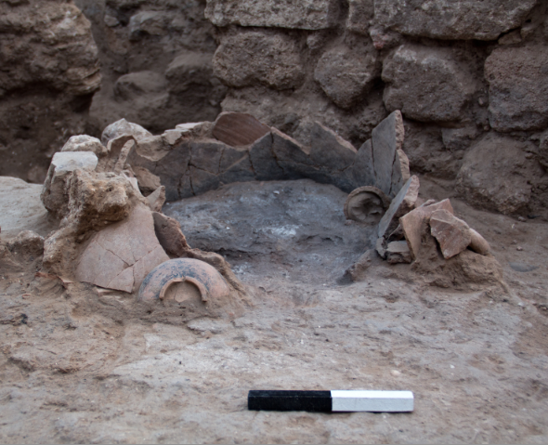
Fig 6. Closeup of Tabun 84.U152. (Photo # 22758)

The small finds and phytolith evidence recovered from the courtyard present a comprehensive picture of domestic industry, most particularly in relation to food preparation. A tabun 84.U152 roughly 50cm in diameter was set into a shallow pit (84.U172/173) cut into the lowest surface of the courtyard, with its doorway oriented to the southeast. Roughly a half meter away was a flat, polished basalt stone facing the tabun doorway that might have served either as a seat while tending to the oven, or as a work surface for the kneading of bread. (see above, Fig. 5) Numerous implements of food preparation were recovered throughout the room. These include a grinding stone and mortar (MC # 66043, MC #65996), hammerstone (MC # 66043), along with blades of both obsidian and flint (MC# 66191 & 66015). An intact cow’s head including one horn core MC# 65893 was set against the southern edge of the wall 83.U52.
Preliminary analysis shows botanical remains of olive and grape seeds, as well as cereals recovered from microarchaeological sampling. Extensive flotation samples were taken by finegrid and phytolith samples from throughout the room, and we await the results of this more thorough analysis over the coming year.
Yet the area was not exclusively dedicated to culinary activity. A total of 1.2kg of iron slag was recovered in several large chunks, most from the area immediately next to the tabun (MC # 65792, 65842, 65885) and an additional sample 2 meters to the south (MC # 66041). This is the largest cache of slag recovered thus far from any room in the grid, and raises the possibility of on-site metal production. Despite the proximity to the tabun, it is unlikely that this oven was in any way involved in metals production as these installations are not constructed to be able to maintain the temperatures necessary for such work. (Though it should be noted that the assumption that tabuns were dedicated solely for food preparation has been the subject of reasonable criticism.) It seems reasonable to assume that the courtyard served as an arena for numerous industries.

Between Buildings 1 and 2 a drain channel, 75.U100 = 85.U41, was constructed down the center of the street either in late Phase VI or early Phase V. This channel was set
offline with the late Hellenistic drain construction, and appears to have used horizontally placed store jars in a row, in lieu of piping, preserved in a few places. Such jars were recovered from the south end of Square 85, where they seem to have been placed in a slightly stepped pattern: the bottom of the northernmost jar is some 20cm above the mouth of the southernmost jar.) Our under-standing of this drain is limited at present as it was cut through by a
Phase IV pit, perhaps a settling area
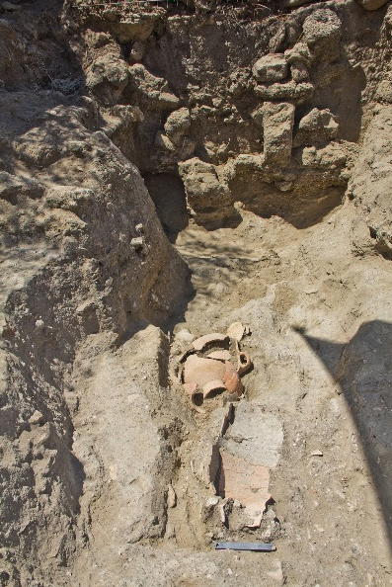
Fig. 7. Pithos Drain (85.U49) in Late Persian/ Early Hellenistic Street.
(view to S)

associated with the sidespout of the Hellenistic drain?). Moreover, as always, it is sometimes difficult to delineate between Phases of Street. As this was only partially excavated due to other priorities within the Grid, we hope to return to this question next season to better understand the Persian period drainage system in this southeastern corner of the neighborhood.

A Note on the End of the Persian Period
The date for the disruption and abandonment marking the end of Phase V is difficult to pinpoint precisely. In Grid 57, the end of the Persian period has dated on the basis of a coin hoard found underneath the floor of Phase 3 Room 341. The 17 coins found therein date to between 305-290 B.C. This break between the Persian and Hellenistic periods in Grid 57 was termed a destruction horizon, and attributed to violence, based on evidence of burning found in Rooms 306 and 103, and the appearance of 2 arrowheads in another non-adjacent space. The destruction has been vaguely attached to Ptolemaic activities in the southern Levant at this time. In Grid 38, a similar ‘destruction horizon’ was noted but during excavation they had great difficulty separating the Late Persian destruction (Phase 10) from a destruction of the previous Persian Phase 11, which apparently caused a great deal of confusion during excavation, as preliminary ceramic analysis also confirms. Moreover from the extant photographs, in many cases it is not often clear that all of the material described as “destruction” and “collapse” are in fact either of those things. Careful examination of those excavation reports, coupled with renewed attention to the ceramic data, will be required to make sense of this transition in Grid 38.
In Grid 51, then end of Phase V seems to be marked more by abandonment than by active collapse or destruction. We lack, for example, evidence of collapsed or burnt roofing material. Moreover even in areas where disruption seems to have been most marked, such as in the Room 15 Courtyard, the interpretation becomes problematic. The latest Phase V courtyard surface, when first encountered, revealed a dramatic splay of pottery (Fig. 8) and pockets of ash suggesting the possibility of fire and collapse or at least hasty abandonment. (See also Fig. 5, above for context).

Closer examination of the ceramics themselves, however, shows that for the most part the splay of pottery does not belong to intact vessels. There are large portions of 2 or perhaps 3 store jars, but apart from these all the rest are mixed, belonging to unrelated vessels. Moreover, the sherds are concentrated primarily in the area shown in the photograph to the right, splaying north into the center of the room from roughly the middle of the southern closing wall 83.U52=84.U100. It may be that these were vessels originally stored upon shelves which later collapsed onto the exposed floor. This would also explain why the sherd density was greatest along this wall. The ash is likewise concentrated in the vicinity of the tabun and thus may be unrelated to the building’s end. These elements, while not contradicting the possibility of a building destruction, do complicate the interpret-
ation. Finer – and in particular micro-
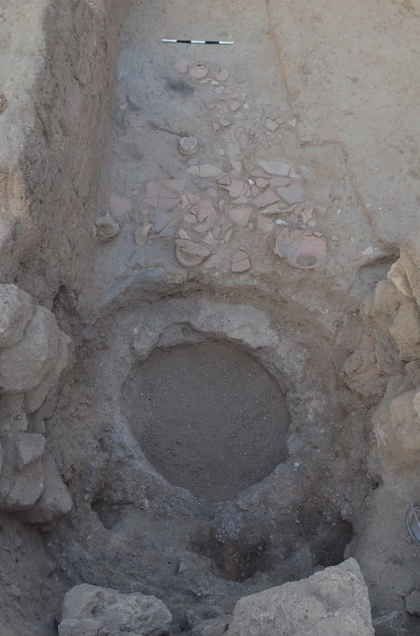Fig. 8 Pottery Splay in Courtyard 15 (view to N; cut through by later well)

archaeological analysis of ash and phytoliths – in other rooms will help bring resolution to this question.
As to the chronology of the transition, the 305-290 B.C. date of the Grid 57 coin hoard has in recent publications been broadly extrapolated to mark the end of the Persian period site-wide. As we refine our chronology, Grid 51 offers an opportunity to address this question anew, to assess both the degree of destruction/disruption and its date. Ceramically, Phase V is the earliest period in Grid 51 in which Hellenistic pottery appears, although these forms are infrequent. As expected, most such forms are East Mediterranean imitations of Attic Black Glaze, and can arguably span the late 4th and 3rd centuries. Likewise forms of Southeast Aegean mushroom-lipped amphora, not produced until after 350 B.C., also appear in Phase V and support a late 4th or early 3rd century date. To this gradual accumulation of ceramic data we can also add three additional coins recovered from Phase V floors, and eagerly anticipate their reading.

Phase IV: Hellenistic Insula
While V essentially constituted a reuse of VI, Phase IV marked a significant change in the use of space in the insulae and a concerted effort at refurbishing the building as a whole. The leveling fills set down for the Phase IV surfaces tended to be quite substantial and were often filled with mudbrick debris and ashlars from the surrounding structure (74.U249, 75.U76, 83.62=73.180, etc.) before the new walls were rebuilt. The Phase IV walls 74.U245, 74.U222, 74.U323, 74.U330, 74.U255, 74.U145, 83.U25 and 83.U56=84.U162 excavated this season tended to be constructed of sizeable fieldstones, have integrated corners and where doorways were reused were integrated into and reused the Phase V-VI ashlar jambs. The only shift in construction pattern was found in the intersections between Rooms 3, 4 and 9. Here, where the E-W Phase V walls 74.U199 and 74.U 2? had been built abutting, the Phase IV E-W rebuild 74.U222 was constructed together with the short N-S stub 74.U255 to form a corner which served as the northern side of the doorjamb connecting Rooms 8 and 9. The N-S wall 74.U245 was constructed abutting this corner, covering the eastern end of 74.199.
Phase IV in the Grid has thus far been characterized by dense occupation in the interior rooms and indications of industrial activity in the rooms proximate to the street. This season Phase IV was exposed and excavated in several rooms in the southern portion of the building Rooms 12 and 14) in areas either further down the step (Room 14 in Square 83) or in areas which had been until recently covered by the large Islamic bathhouse walls 74.F9= 73.F20 (Room 12 in Square 74). The Hellenistic courtyard (Room 15) contemporary with these rooms was also excavated this season.
The greatest - and yet the emptiest - density of Phase IV occupation was revealed in Room 14 in the far southwest of the Grid. Here a series of three surfaces accumulated in relation to the exterior courtyard space in Room 15. Rooms 14 and 15 were separated not only by the doorway on the southern end of 83.U25, but also by an additional mudbrick and ashlar threshold 83.U70=77. This substantial threshold was positioned E-W and abutted the western edge of 83.U25, to prevent courtyard materials from being tracked into the interior space of Room 14. The placement of 83.79=77 thus marks not only a doorway, but indicates that there was likely an E-W wall extending to its west, the edge of which lies just beyond Square 83’s western edge. Within Room 14 (north of the threshold) were a series of three occupational surface accumulated over a span of some 30-35cm (83.U80, 83.U78, 83. U67). Despite the depth of occupation, these thin striations produced little in the way of occupational remains, the exception being faunal material and a single flint blade (MC#66113).
In Room 9, the last remains of the heavily disturbed Phase IV surface 74.U373 were removed, along with the partially preserved mudbrick platform (?) 74.U369 upon it. As discussed in the 2010 Square 74 Report, the surface had only been preserved in the very center of the room and the remainder of the space had been utterly wracked with pits and disturbances containing mudbrick debris and the chunked up remains of surfaces. The landscape and nature of the debris suggests an end-of-phase destruction of some sort of large plastered installation - presumably involving some sort of subfloor basins, given the size of the pitting actions - within the room.
In Room 12, defined in this phase by 74. U334 to the east, 74.U145 to the north and 74.U187 to the west (the southern wall robbed by the E-W trench 74.U265), a phytolith rich surface with very dense areas of burning and charcoal was uncovered. In contrast with the Phase V phytolith surface which preceded it, the microarchaeological reports show that the thick white deposits on this surface were not cereals but rather quantities of straw and grass, perhaps indicative of grass matting. Additional finds from this floor include a coin MC# 65583, a bronze pin MC# 65852 a netting needle MC # 65654, and a single lint blade MC# 65746.
As in the preceding phase V, the courtyard (Room 15) was accessible from rooms immediately to the east and west (14 and 16) through doorways built with ashlar jambs. It was delineated by wall 83.U25 to the west, 83.U56=84.U132, on the east by the robbed wall 84.U18. Its southern boundary probably ran along the southern baulk and was robbed by a Fatimid trench. Both the eastern and western doorways had constructed thresholds; the eastern access (84.U123 = 84.U135) utilized stone steps and the western mudbrick curbing/steps (83.U72).
The courtyard space showed indications of industrial use, although different in nature from the Phase V courtyard which preceded it. A wide patch of hydraulic plaster was set down on the surface 84.U117 in an area immediately adjacent to the doorway to Room 15. The plaster was quite thick in some areas, up to 3-4cm thick. The plastered surfaces appear to be coating a clay-lined depression sloping against the (now-missing) eastern closing wall 84.U18. Ephemeral patches were likewise noted in the south of the courtyard, and identical hydraulic plaster was also recovered from the surface in the adjacent room to the west, 83.U67, and can even be seen in the 83 West Section passing over the threshold 83.U77 and lensing out as it moves further north into Room 14.
The shift from standard to hydraulic plaster is apparently the result of the deliberate addition of silica to the mix, an outcome which can crudely be achieved using simple materials such as sand. While the Phase IV plaster contains enough silica to mimic the chemical signature of hydraulic plaster, its consistency and composition is remarkably soft for this species of plaster. Thus if it is indeed hydraulic plaster, it is a poor form of it. Notwithstanding, the use of this specific type of plaster, coupled with the thickness of its application, suggests a serious concern with liquid retention and permeability that exceeded the abilities of more conventional plasters or the favored hamra clay. It may simply increase the resilience of the plaster when exposed to liquid, where hamra might require continuous reapplication. Without any additional data, however, we cannot presume to identify the industries being conducted here. Botanical samples were taken from the area and we await these and the corresponding phytolith report.
The FTIR suggested that in some, though not all areas, both the plaster and the clay lining were heated to over 600 degrees; however the microarchaeologists on staff also noted that it is possible that such a reading might also result from the rapid transfer of newly made plaster from a nearby place of manufacture to the surface upon which it was being applied. We can only note that the space seems unlikely to have been configured to produce plaster in situ. A more likely source would be the lime plaster bins excavated in 2010 from Building 2 across the street.
While it is not possible to reconstruct specific installations in this Phase IV, it is clear that the nature of the courtyard changes in the Hellenistic period, the transition marked by a shift away from the domestic/culinary use towards the industrial, although the phytolith data should better illuminate the distinction, once received. This shift in activity continues the pattern seen in other rooms of both insulae during this Phase. Additional evidence, albeit thinner, for industrial activity in Building 1 during this phase may be the patches of kurkar surfaces, perhaps to accommodate drainage, that were noted in the southern edge of Room 11 (84.U90) and the northern edge of Room 17 (84.U167, exposed but not excavated this season.)

Phase III
As noted in previous reports, the surfaces attributable to Phase III were largely removed by bulldozer, but are yet visible in the eastern section of Square 75. Excavation of significant portions of Islamic robber trench in Squares 84 and 85 this season also illuminated a sequence of floors which can similarly be tied to the Phase III horizon by elevation. These surfaces were cut through by the Islamic trench 85.10 but are visible in the south subsidiary section (Photo # 9784).
Several Phase III surfaces were excavated during the previous season in Squares 83-84. This year we removed the subfloor fills for these floors. In 2010 the Phase III fills in Squares 65 and 75 produced some of the richest finds of the season, including a series of Rhodian stamped amphora handles dating to the mid- 2nd century which provided a tpq for Phase III. (MC #s 63206, 63106, 62249). To this collection we can now add another stamped Rhodian or Knidian handle MC#66221, recovered from the Phase III fill 84.U71 (Room 16) in the southeast of Square 84.

As preseved, the handle as reads, in two lines: ΕΠΙ....ΚΡΑ[.... .Two names are attested which begin with the syllable ‘Κρα’; Κράτης and Κρατερός, both of which date to VR Grace’s Period VI, 108-88 B.C. However, names in such handles quite frequently span two lines, and it is therefore possible – and perhaps even likely, given the spacing – that the -κρα- is instead a syllable in the midde of the name. In this case the –κρα - syllable is probably to be completed κρα[της or κρα[τευς.
Unfortunately there are over 18 names containing a –κρα- element attested on Rhodian handles, and while

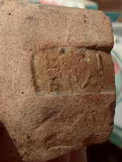
Fig. 8 Rhodian Stamped Handle
(MC # 66221)

most of these cluster in her groups III-IV (220-146 B.C.), such names can span the entire range of forms from periods III-VII, up to the late 1st century B.C. (Grace 1985:35). The previous collection of handles (MC#s 63202, 63106, 62249) suggested a date in the late 2nd century B.C.
The final piece of Phase III was noted only at the end of the season and remains poorly understood. It appears that a circular pit, or perhaps settling channel, was cut down through the street in either Phase III or Phase IV (the uppermost portions of these streets having been removed by bulldozer in the original cut of Square 85).

Phase IB: Islamic Robbing Activities
This season also witnessed the long-anticipated end to most of the seemingly bottomless Fatimid-Crusader robber trenches, several of which had reached over 2m in depth. All continued to provide remarkable examples of well-preserved Islamic pottery. Most appear to have bottomed out just above Phase VI. The only trenches which remain to be bottomed out are those in 85, the southern E-W trench of 84, and the northern trench in 74.

Phases IA – II
No material from these phases was excavated in 2012.

Note for the 2013 Season
Two areas lag behind and will require additional attention in the 2013 season in order to bring them into Phase: Square 85 has for the past two season only been excavated part-time, in an effort to focus on areas immediately adjacent to architecture and as such lags in Phase IV (Hellenistic.) The overlapping cuts and side channels of several superimposed drainage systems are clustered here, and there are questions that lack resolution in this area which should be attended to.
Likewise, the southeastern section of Square 84 served as the foundation for the sandbag staircase and exit from the Grid, and as such could only be excavated in a limited fashion this season. This area was heavily disturbed by the Islamic robbing activity but is currently also in Phase IV. Repositioning of the fence and the expected 2013 expansion should allow for new routes of egress and provide the chance to excavate these out of phase areas more fully.

Thanks are due to directors Larry Stager and Daniel Master for the continuing opportunity to participate in the new phase of the Ashkelon Expedition.

The sandy street layers of 75.U89 and 75. U86 Phase VI and V streets, respectively can be seen accumulating above the doorway connecting Room CFE to the street. Above these – also visible in the doorway thankfully preserved in the baulk between 74 and 75 – we see also the start of the Phase IV backfilling of the street and this room (75.U76, 74.U249)
M. Garrison et al. (eds.) Persepolis Fortification Seals Vol. 1: Images of Heroic Encounters (2001), Cat. No. 230.
Dusinberre, Aspects of Empire in Achaemenid Sardis
Given the pattern of rebuilds within the space, it seems likely that 84.U18 was similarly rebuilt in 4; however with only the ashlars of the doorjamb remaining it becomes impossible to reconstruct the division. This is particularly true given the Grid-wide pattern of reusing the ashlar jambs – by far the sturdies portion of the wall – while relaying courses of rubble fill.
From Tabun 84.152: Sediment Samples 1055-1063; From early Phase V surface 83.U85=U161 From upper surface 83.65=119 Sediment Samples 889-894, 959-965, 995-999.
The difficulty in delineating the break between Phase V and Phase VI street (75.U76 and U89, respectively) renders the clear attribution of this early drain to one or the other somewhat challenging, given that the sandy composition of the street is difficult to distinguish from the sandy composition of the drain itself, and organic leeching has altered the color of both. The north section, however, seems to show the cut beginning in the Phase V street. (This difficulty will be resolved with further excavation next season).
MC # 31620, 57.68, LF336.
M. Lawall, “Ilion and Alexander: Amphoras and Economic Archaeology,” Studia Troica 12: 197244, 2002, nos. 81-84.
MC# 65758 from 74.U184=392 in Room 11; MC # 58281 from 74.U192 in Room 3; MC # 65838 from 84.U151 in Room 16.
Collapsed ashlars of 75.U76 are visible in the final 2011 Grid photo (see 2011 Grid report title page.)
Installations for making lime plaster in Building 2, evidence of burning installations and thickly coated hamra floors in Rooms 9 and 13 of Building 1. See 2010 and 2011 Grid reports.
Such an east-west wall can be seen to have existed along this line during Phase III, as the precisely aligned E-W robber trench 83.U26/7, visible in the west section, demonstrates.
84.U117 Sediment Sample # 905, 83.U67 Sediment Sample # 926. Presence of silica was confirmed through FTIR.

