LEON LEVY EXPEDITION TO ASHKELON
GRID 51 FINAL REPORT 2011
K. Birney

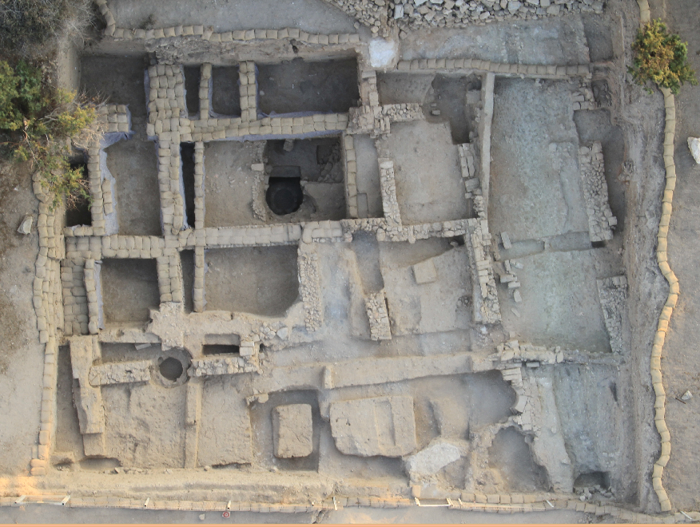
Grid 51 Overview at the Conclusion of the 2011 Season (Photo # 19278)

Grid 51 Professional Staff Grid 51 Volunteer Staff
Laura Wright Ben Conner Caroline Lauer
Larry Largent, Jr. Greta Fleischner Katelyn Martin
Sara Hoffman Helen Freeman Stephanie Morse
Casey Sharp Hunter Gaylor Erik Perez
Hilary Smith-Wikle Aleah Goldin Andrea Ruiz-Lopez
Katherine Hooge Noah Goodman Melvina Stemley
Mr. Coffee Victoria Jenkins Peter Strobel
Emma Kouvanes Michael Yu
Rachel Lieb

GRID 51 FINAL REPORT 2011

Season Objectives
2011 saw another fast-paced and intensely productive season of excavation in Grid 51. The upper areas of the Grid – areas which had only seen one prior season of excavation – were the primary focus of excavation, in an effort to bring them closer into phase with the lower Persian period building uncovered in squares 73E and74W in the preceding years. Omitting only those Fatimid period robber trenches which could not be safely removed to their full depth, we successfully excavated all Islamic, Byzantine and Late Hellenistic-Early Roman period remains, and brought these more recently opened areas into Phase V and IV, the early and middle Hellenistic periods, respectively.
A secondary goal was to ascertain the depth of the 604 B.C. destruction levels in relation to the excavated Phase VII Persian period floors, in order to establish our excavation goals for the next five year sequence at the site. This was accomplished through
the opening of a ca. 2 x 3 m probe in the CE room, adjacent to the well 74.F11, exposing more of a sequence of layers first identified in the section of the well probe 74.F200 in 2008. Both the Hellenistic period and the Iron II objectives were achieved through the tireless efforts of 19 volunteers under the most excellent supervision of Square Supervisors Sara Hoffman (75 and 85), Larry Largent (74)and Laura Wright (83-84) and Assistant Supervisors Hilary Smith-Wikle (74) and Casey Sharp (83-4). I am grateful to each of them for their work ethic, patience and humor.

Phasing and Chronology
With the addition of the Iron Age probe, Grid 51 now has been shown to have occupation in at least nine chronological Phases.

Phase I: Islamic (Fatimid-Crusader, 10th-12th c. A.D., 2 subphases)

Phase II: Byzantine (4th-7th c. A.D.)

Phase III: Early Roman (late 2nd B.C. – 1st. A.D.)

Phase IV: Late Hellenistic (ca. 3rd-early 2nd c. B.C)

Phase V: Early Hellenistic (ca. 350-290 B.C.)

Phase VI: Late Persian (ca. 400-350 B.C.)

Phase VII: Persian ( ca. 500 B.C – ca. 400 B.C.)

Phase VIII: Iron IIC (7th century)

Phase IX: Pre-7th century

Of these, Phase VIII has been exposed only in the 2 x 3m area of the probe, and Phase IX only in the section of the same. These Phases will not be broadly excavated until the 2014 season.
The 2011 Season results are presented below in chronological order, from earliest to latest. Readers are encouraged to consult the final reports from 2008-2010, which present a complementary picture of the Phase IV-VII rooms not excavated in 2011.

Phase VIII : The Iron Age Probe

Three occupational horizons were observed while removing several courses of the Square 74 well 74.F11 to establish a vertical section for a probe in the CE_{E} room. Some 40cm below the Phase VII surface 74.U287 appeared what has now been deemed the 604 destruction horizon. Below this, separated by a shallow fill, are two darker horizons: a band of thick grey ash, some 15 cm in depth, and a second area of dense and very dark ash starting at c. 14.33m above sea level and continuing down beyond the current lowest excavated point in the well. Material collected from the uppermost (604) horizon was 7th century, the material from the lower two ash horizons was entirely Iron I, including several Philistine bichrome krater sherds and bell-shaped bowls. There was no Iron II pottery recovered from the intervening levels, suggesting that there may be a gap between the 11th century and the 7th century in Grid 51. Having secured the horizons above (Persian 74.U287) and below (Iron I) our targeted 604 sequence, we continued to excavate in the eastern portion of the CE_{E} room.

The 604 Sequence
The earliest surface excavated within the expanded 2 x 3 m probe in the CE_{E} room was the ashy horizon 74.U322. 74.U322 lipped up to a NW-SE running wall 74.U301=302 (the midpoint of which had been robbed out by the Islamic well 74.F11) to its south, and to a stone wall or bench 74.372 in the east. The intensely sandy nature of the laminations which accumulated above this floor (74.U381, 365, 368, 364) suggests that it was followed by a horizon of exposure and abandonment, during which silt and sand washed in from areas to the east (as indicated by the gradual tip line in the north section of the probe).
The ephemeral layer 74.U324 was the latest of the Phase VIII surfaces, a thin line of ash and sand set over these fills which lips up to the kurkar-filled stone bin 74.U376 in the west, and up to the uppermost course of a stone bench/step in the east 74.318. Two intact 7th century cooking juglets (RP #11822s and 11931), the latter having been misfired green, were set on this horizon, along with a fragment of an Assyrian ware plate (RP#11824) and a dipper juglet (RP #11916) . One of the cooking pots sat immediately to the west of a burning pit 73.U367, around which were several collapsed tabun fragments. On the other side the deposited remains of a meal, fragments of cow and goat, had been deposited.
In the northeast corner, a small patch of charcoal with small chunks of burnt mudbrick in it, approximately 5cm in depth, was set on 74.U324. This last, and the line of burning noted on the interior (western) face of the bin 74.U376 were the only evidence for any sort of destruction or collapse in association with this horizon. Ceramically, these layers all seem to fit within the late 7th century. A single piece of East Greek Wild Goat II pottery (production dates 625-600 B.C.) was recovered from 74.U364, the fill below 74.U324. Above 74.U324, some 50cm of leveling fill, 74.306, was set down in preparation

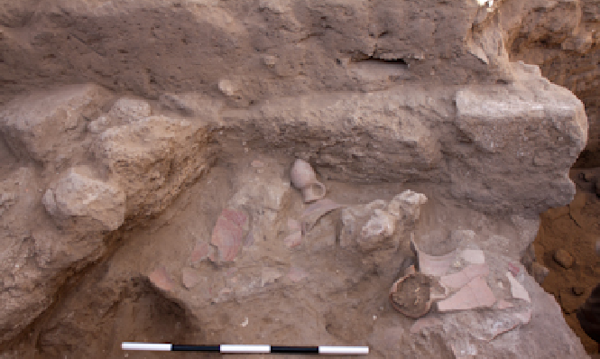
Fig. 1 7th century vessels on surface 74.U324 (Photo # 18973, view to SW)

for the construction of the Phase VII Persian building. Unsurprisingly, U306 contained predominantly Iron Age pottery with a few body sherds of typical Persian fabric.
This ceramic window notwithstanding, it should be noted that there are some difficulties in fully accepting 74.U324 as The 604 Destruction, not least of which is the presence of substantial amounts of sandy laminations with seventh century pottery which occur beneath it. This would imply that the area was abandoned for a time prior to the construction of the late seventh century building which Nebuchadnezzar was later to destroy. While eighth century horizons at Ashkelon have been notoriously thin or absent, there is no comparable evidence elsewhere at the site for an abandonment in the seventh century, followed by a short-lived late seventh century rebuild immediately prior to the Babylonian destruction.
The sparse evidence for destruction or collapse, the fact that the tabun associated with the surface was neither intact nor complete – which would be expected in a preserved destruction layer – coupled with the sand evidence which points to an occupation and abandonment immediately prior to this phase rather suggest that 74.U324 might well be a reoccupation following the 604 destruction. While the appearance of Wild Goat pottery in the subfloor fill shows that the horizon must postdate 625, it in no way provides a terminus ante quem for 74.U324. It is not inconceivable that some reoccupation at the tel might have occurred shortly following Nebuchadnezzar’s destruction of the city, if even for a short while. Similar reoccupations were noted in Phase IB at Ekron, for example, or at Tell el-Ful. Nor, given the long lifespan of certain forms is there any specific ceramic evidence which definitively negates this option. It is possible that the destruction layer might belong to a lower horizon – perhaps not yet excavated. A complete storage jar (Rp# ????) and cooking jug were recovered from within the fill levels 74.364=368=365. During the course of excavation it was presumed that they were vessels which sat upon the lower surface 74.382. Subsequent excavation showed, however, that the base of the jar is resting below this surface, presumably on a lower – as yet unreached – horizon. Alternately, it is possible that this complete jar and cooking pot were in a pit cut from the higher surface 74.U324, which was missed, although pit lines were actively sought.
We present these reservations not to necessarily argue in favor of a 6th century reoccupation on the basis of a 2x3m area, but merely to note that the evidence for a 604 destruction in this area is not as clear as might be hoped. The Weizmann Institute has sampled extensively from the surfaces associated with the Phase VIII-IX horizons for FTIR, phytolith and micromorphological study. It is hoped that their results will help us
to better understand the sequence uncovered in this probe. In particular, we hope to learn :

- the nature of the phytoliths in the charcoal area on 74.U324, and whether they could be indicative of roof collapse (i.e. palms, roofing reeds)
- whether or not the burning in this charcoal area occurred in situ
- whether the horizons beneath U.324 show clear microevidence of abandonment

These answers should be available by the start of the 2012 excavation season.

Phases VII-IV: The Persian – Hellenistic Neighborhood
Grid 51 encompasses nearly all of one Phoenician-style insula and the westernmost edge of a second, separated from the first by a broad north-south street. Building 1, the original insula, was constructed in the 5th century B.C. and was reused continuously along the same wall lines well into the Early Roman period. While most of the architectural plan is well understood, each season brings a bit more clarity to the layout and syntax of the space. Fig. 2 below reflects the our current understanding of the plan of Building 1 and the surrounding neighborhood as of this season’s end.

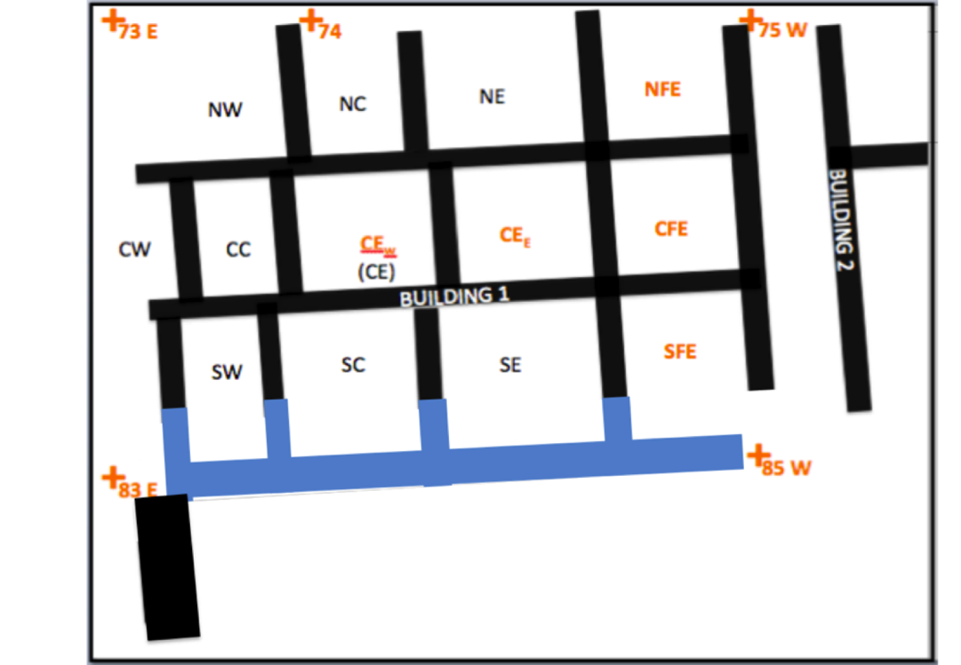
Fig. 2 Grid 51 Persian-Hellenistic Neighborhood plan as currently exposed
(view to N, changes from 2010 indicated in blue)

The basic room layout and wall lines were discussed thoroughly in Grid Reports from 2009 and 2010. 2011 focused upon the eastern (74) and southern rooms (83-84) of Building 1, the western edge of Building 2, and the street dividing them. This season’s work confirmed that Building 1 does indeed continue south into Squares 83 an 84, and that the wall 83.2 = 84. U3 (and its predecessors which serve as its foundation) represents the southern closing wall for the rooms seen in Squares 73 and 74 south in most subsequent phases. Moreover, the discovery of a number of doorways, most of which were functional in Phases VI-V, now allows us a better sense of building use patterns. (See “A Note on Doorways” under Phase V, below)

Phase VII Early: Early Persian
Phase VII has been excavated in most of the rooms of Building 1 in 73E and 74W during previous seasons. This year, preparation for the Iron Age probe in the CE_{E} room of 74 Lower revealed the earliest subphase of Phase VII within this space. The Phase VIIB floor, 74.U287, had been reached at the end of the 2010 season but thoroughly sandbagged to protect it from winter erosion and minimize contamination. This functioned with the foundation stones (74.U375) of the Phases VII-V mudbrick wall 74.U201=211 to the south but in the north clearly run under the Phase VI closing wall. Later within this Phase, the N-S dividing wall 74.F282 was constructed and included a doorway which connected the eastern and western halves of the CE room. Apart from a glass bead (MC#63301), some small bits of metal and slag, there was no material culture to indicate the use of space. We note only that both on this floor and the Phase VIIA floor above it (74.U284) copious amounts of reddish hamra clay were smeared on a number of the floor laminations, presumably as a sealant of some kind. (See below: “A Note on Hamra”).

Phase VI:
No Phase VI remains were excavated in 2011.

Phase V (Late Persian-Early Hellenistic):
Phase V spans the transition between the Late Persian and Early Hellenistic periods, and is characterized by the reuse and rebuilding of the original Phase VI mudbrick floor building. It was broadly discussed in both the 2008 and 2009 reports (appearing in the former as Phase “3C”), and a revised understanding of the SW room in Building 1 was presented in the 2010 Final Report.
This season Phase V remains were excavated in the CFE and NFE rooms of Square 74. The CFE room was defined in this phase by the substantial stone walls 74.U342 and in the north, 74.U323 in the west, 74. U330 in the south and a substantial ashlar wall 74.U341 which fronted the street in the east. The connecting CE_{E} room shared the closing wall 74.323 on its eastern edge, and was limited by 74.194=144 in the north and 74.189=73.F153 in the south. CFE and CE rooms were connected by a doorway in wall 74.323 with an ashlar and cobble threshold 74.U348.
Occupational debris associated with Phase V surfaces has tended to be quite sparse, the only exception being the CC room (discussed in 2009) and the NE room (discussed in 2008), each of which showed some occupational buildup and small cooking hearths. Beyond these rooms, however, Phase V was marked by minimal occupational debris, capped by evidence for abandonment in the form of layers of sand or clay. This pattern continued in the CE and NFE rooms, where clay and sandy surfaces 74.354 and 74. 352 showed only sparse signs of use, yielding only a small sampling of metal bits, a flint scraper (MC# 64576) and a hammerstone. (MC# 64577). The only material culture of note was a fragment of a terracotta sculptural element recovered just above floor 74.U354 (MC#64808). The preserved fragment, showing an eye, eyebrow, and coiled hairline, is typical of Etruscan and Greek Gorgoneion antefixes. Such architectural elements were apparently affixed to the eaves of temples or shrines (Stern 2010: 47-51). A complete parallel exists at Dor (Martin, forthcoming), where they are interpreted either as antefixes or masks. Our fragment, in addition to having no eyeholes, is made of rather thick and solid terracotta and as such seems ill-suited for the latter.

A Note on Doorways
A series of doorways functional in Phases VI and V were noted this season, most of which seemed to have been deliberately blocked up at the outset of Phase IV. These included an entrance into the NFE room from the north-south street, and a series of connecting passageways into the center of the building. These doorways tend to be marked by large cut ashlar jambs, regardless of whether the superstructure is mudbrick or stone. In one instance, (83.U18) the ashlars of the doorway are all that remains of the entire wall line, the rest having been robbed out.

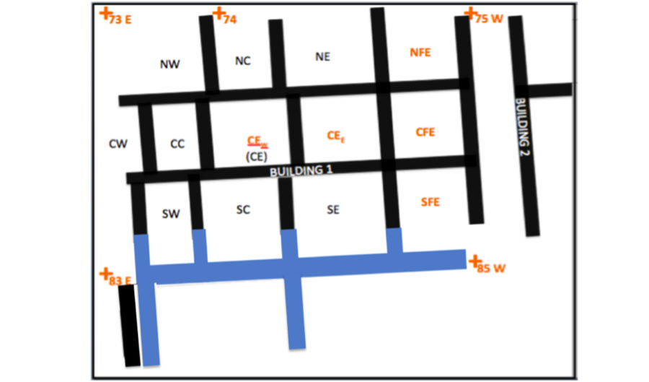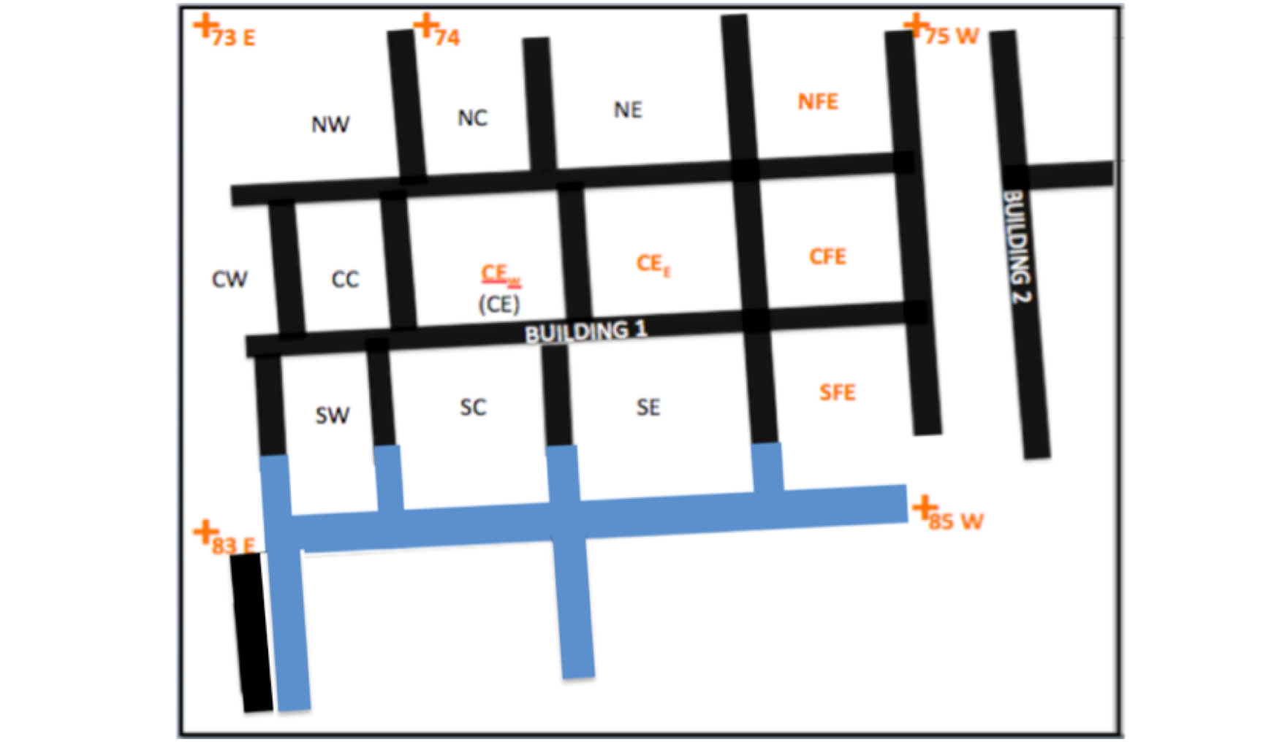
Fig. 3 Phase VI-V Building plan showing doorways.
Doorways in red function in VI-V; doorways in yellow function in IV; earlier use unknown.

The majority of the doorways preserved seem to have an E-W orientation, perhaps facilitating flow from the street into the interior rooms of the space In the 2010 Final report, we discussed the “duplex” nature of Phoenician insulae and noted that sometimes the alignment of doorways could help to reconstruct the original dividing wall of the building. If this methodology holds true, then perhaps the northern/southern division may be accurate, making the wall 74.F201=211 the E-W backbone of the duplex. The differences in material and construction techniques between the eastern and western halves of the building noted last year, however, should still be considered in addressing this question.
Of particular note was a doorway constructed in 74.U323 (Fig. 4b), connecting the Phase V CFE with the CE_{E} room. This doorway had a sizeable jamb of three or four beautifully cut ashlars, into the top of which were two drilled slots set 2 cm back from the eastern wall face (See Fig. 4), perhaps to support a wooden superstructure. On the west side of the door, a rectangular hole had been drilled into one of the stones in the abutting E wall 74.U199=144, perhaps for a bolt or other locking mechanism (Fig. 4a).

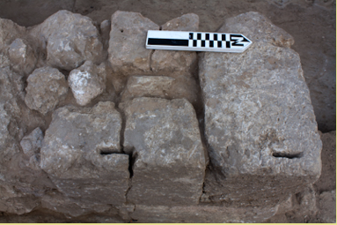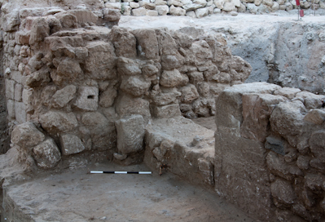
Fig. 4a and b Doorway in Wall 74.323 connecting CFE and CE_{E} Rooms
Photo #s 18979 (left, view to W) and 18965 (right, view to NE).

Phase IV (Hellenistic): An Industrial Neighborhood

Phase IV surfaces were excavated this year in the NFE, CFE and SFE rooms of 74, in the western half of Square 83, and in northern fragments preserved within Square 85. Phase IV floors were reached but not excavated in the center of 83.
Phase IV was marked by a nearly total rebuild of the original Persian period insulae. Deep fills were laid down throughout Building 1, and the Phase V walls - some remaining intact as they fell - were collapsed both on the interior and exterior of the buildings to level the space for new construction. In some cases the building material collapsed inwards included a host of well-cut ashlars (i.e., 74.U357 in the CFE room). That the Phase IV builders chose to ignore such substantial building material is surprising. However it is clear that the while some of the ashlars of U357 lay close to or on the floor, many others were clearly deposited in and around the fill 74.U249. The same pattern can be observed in the street, where a fill layer (74.U76=74.U249) identical to that deposited inside the CFE room can be seen to have spilled into the street, with ashlars in it. The quality of the fill itself is clean and brown, and lacks the characteristics of either destruction debris or street material. It may be that an earthquake or other event triggered the initial collapse, and that subsequently it became necessary to deliberately collapse the remaining walls. In any event, some very nice building material was abandoned in these leveling fills.
In the east of the Grid, thick laminations of sand (75.U83) mark the abandonment horizon at the end of Phase V. Some street debris (75.U78) accumulated atop this sand horizon on the eastern edge of the street, and washed around the remaining stub of a standing Phase V doorjamb/wall segment. Above this, the builders of Phase IV constructed a N-S wall 75.U39 integrating it with a pre-existing Phase V door jamb on its southern edge, and rebuilt the southern extension of this wall 75.U61=69. Within the Building 2, a leveling fill 75.U was set down and three mudbrick-lined installations 65.U2=75.59=75.51 and 75.55/56=75.U44=75.U23 were set down below the floor .
In the street itself, Phase IV is marked by the construction of a large drain (75.U16=85.31) which ran the length of the street and sloped down from N-S. The west side of the street was paved with flat stones (75.U66=85.U18) which ran up to a well 85. U23 and its adjacent platform 85.U6:

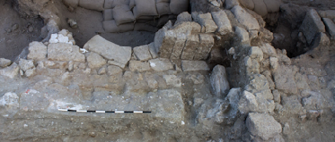
Fig. 5 Phase IV Hellenistic well 75.23, well platform, and paved street 75.66=85.18
(Bisected by the 75-85 baulk. Photo 18824, view to W)

Within Building 1, the Phase IV builders erected new terrace walls 74. U222 and 74.U245 separating the NFE rooms from CFE and NE, respectively, within which the floor 74.U246 was set down. The CFE room is defined by the pier-and cobble wall 74.260=241=240 (which blocks up the Phase IV doorway out into the street), Walls 74.U255 and 272 form a narrow staircase or storage room adjacent to CFE. The SFE room was defined by walls 74.U330 in the north, 74.U334 in the west, 74.U328 in the east, the southern closing wall having been lost to the E-W Islamic trench 74.U265.
Phase IV in both Buildings is characterized by industrial activity in the rooms which lined the street 75.75=78. In Building 1, the floors of both the NFE (74.U246) and the CFE room (74.U253) and its adjacent storage area (74.U272) were thickly lined with a plaster made of hamra clay mixed with shell fragments. While its purpose is unknown, it may have been lined thus to be capable of supporting greater weight, or as a protective coating in the presence of liquids. The presence of a small buttressing wall 74. U254 on the southern edge of 74.U222 may support the former notion. (A similar cobble buttressing wall (75.U81) was noted in Building 2, set just inside the doorway abutting the north edge of wall 75.U61, likewise immediately underneath the Phase IV floor.)
In the SFE some sort of large installation was constructed though it is impossible to reconstruct its precise function as it was heavily damaged by later pitting activity and the Phase II vat construction. The constituent remaining parts include only a grey mudbrick platform with plastered southern edge 74.U369, an adjacent pottery-and tabun-fragment-lined surface 74.U373 which sloped up to this platform (possibly plastered over?). The installation was uncovered in the final days of excavation and will have to be further explored next season.
In Building 2, a series of bins 65.U2=75.59=75.51 and 75.55/56=75.U44=75.U23 were constructed. The southern bin was fully excavated in 2010, and the construction of both was described in detail in the 2010 Grid report. The northern bin was excavated this season, and while its hamra and plaster lining was identical to its southern brother, this installation preserved a thick layer of burnt shell (75.U58) in its interior. The shells within had been heated sufficiently to transform their naturally occurring aragonite into calcite, which is essential for the production of the lime used in mortars and plaster. It is unclear whether the sediments in this installation were burned to a high enough temperature for these shells to be in situ evidence of shell lime production. (This answer requires the establishment of a new temperature baseline for the reddish hamra soil used to line the installation; see “A Note on Hamra”, below.) For the present, however, it seems reasonable to presume that the shells are in situ, an artifact of the installation’s use, rather than a secondary dump of burned shell. If the temperature range is sufficiently high (above 700 degrees) then this may well have been a facility for the production of lime plaster.

.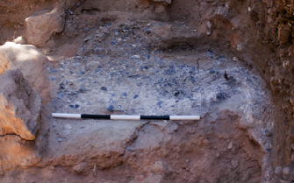

Fig 6. Shell lining 75.U58 in installation 75.55=44. (Photo 18961, view to N)

The Phase IV interior rooms of Building 1 excavated in 1999-2000 and 2008 (NE, NC, SW, SE) did not show any clear evidence for industrial use. This appears to also hold true for the southernmost row of rooms in Building 1, in Squares 84 and 84, although these areas are admittedly quite small, consisting only of three patches of floor on the southern edge of the SW and SC rooms, (83.U50 = 73.152 and 84. U117) respectively, and the remains of what may be a strip of exterior surface 84.U113. This creates an interesting picture of the use of space within the neighborhood insulae where, as one might expect, the rooms facing the road would be best suited either as shops or workshops. The ready proximity of water from the nearby well would have been convenient for many of these manufacturing industries.

Phase III

Phasing within Grid 51 in the after the Late Hellenistic period is generally challenging in that the proliferation of Fatimid robber trenches not only robs of us connections between rooms, but even severs connections within rooms, or removes whole rooms in their entirety (vis. 84. 11=63, 85.U10/11, inter alia.) The patchwork remnants have been stitched together but the picture of Phases I-III remains incomplete. Phase III remains particularly fragmented. Indeed, over the past few years there has been some discussion as to whether a clear Phase III – a Roman phase – is attested within Grid 51. Ceramically, this is a difficult horizon to define, being that the ceramic seriation marking the end of the Hellenistic and the beginning of the Roman period is hazy. Those forms which are known elsewhere in Israel to be diagnostic (such as Nabatean wares) do not seem to appear at Ashkelon. Those forms which can be defined as middle Roman seem to appear in Grid 51 only in the later (Byzantine) materials, and cannot be confined to their own phase. What remains is a selection of layers which express this transitional horizon between the late Hellenistic and early Roman, with forms that span the 1st centuries B.C. to the first or early 2nd centuries A.D. With only a few exceptions they lack clear architectural connections. These early Roman assemblages fall in layers – and sometimes floors – which tend to fall third in the progression of floors from the latest Islamic material down to the Later Hellenistic. For this reason, we are preserving an elusive and highly unsatisfying Phase III within the grid, in the hopes that it will be better understood in future seasons.
Disconnected surfaces in Squares 83 and 84 have been assigned to Phase III on the basis of these criteria. Apart from these small hints, it is very difficult to reconstruct a full picture of the buildings in which they functioned. These include the sandy courtyard layers 83.F59=105 defined by the wall 84.F46=84.F3 in the north and 83.U5/12 in the west, and probably on the south by the meager remaining stones of wall 83.U9=84.115. In the SW room, an ephemeral surface 83.272 was noted running up to the wall 83.U39=73.F7 in the east and 73.U44=73.137 in the west. No material was recovered from this floor. The richest occupational debris from this Phase was recovered from interior surface 83.F63, west of wall 83.U5/12. A cache of eight unbaked clay loomweights (MC#s 64631-2, 64685-90), a cylindrical bone bead, and what appears to be an iron blade or tool (sword?) measuring nearly three quarters of a meter in length were recovered from this floor (MC#64769). The pottery from this horizon has ranged from Hellenistic to Early Roman, with the latest material being clearly 1st century A.D.
In Square 84, a ca. 3x2 island (surrounded on all sides by Islamic robber trenches) of floating surfaces 84.F93 and 84.F102 were assigned to Phase III on the basis of ceramic evidence and their sequence. Further the east, exterior surfaces were excavated in the thin (0.50m) strip which remained between the two Islamic robber trenches 84.U11=63 and 74.U265.
Very little of Phase III was preserved in Square 74. In the NFE room, the northern section preserves a small fraction of what may have been a Phase III surface 74.U238 on the highest step north of wall 74.U222, the rest having been bulldozed away. Any remnants of Phase III in the CFE room would similarly have disappeared in the jaws of the shufel, with the exception of remaining pits. In the SFE, some patches of the diving surface coated with chalk plaster, 74.U373 might be part of an earlier vestige of industrial activity in the area. Generally, however, the Phase III horizon was heavily disturbed by pitting action in association with the construction of the later Byzantine wine vat and associated facilities.

Phase II: Byzantine Wine Production

The Byzantine “villa” was first described in the 1999 Grid Report. It reused in part the original wall lines of the original 5th century Phoenician insula, in particular the Phase IV walls. The only additions noted in 2011 were in the construction of the ashlar walls 74.U 251 and 74.U230=75.10, which defined the northern and eastern limits of the SFE room in both this and the subsequent Phase IB.
Preserved floors of this building were excavated in 1998 between the well-built ashlar walls 74.F5, 74.F7 of the NE and NC rooms, and yielded a an impressive assortment of decorative and prestige objects. These included an array of bone and ivory cosmetic accessories including a bone spoon, two kohl sticks (MC #s 50652, 50653), 6 coins, beads and intact glass vessels from floor 74.LF60. In 2011, small patches of Phase II surfaces came to light almost immediately underneath the shell concrete of the Islamic bathhouse, separated from the above only by shallow layers of brown silty fill. In Square 84 surfaces 84.U84 and 88 in the west and 84.85 in the east, separated by a N-S wall stub 84.U78, yielded a similarly rich assemblage, including a bronze ring ((MC# 64202), four coins (MC #s 64244, 64285, 63682, 64330), glass beads (MC #s 64131, 63696), two bronze pins and a fibula (MC#s 64144, 64290, 64553), a Late Period scarab (MC# 64517) and a worked bone hairpin (MC# 63673). The consistency in both the number and nature (items of personal adornment) of the finds from the 1999 and 2011 seasons support the interpretation of this building as private and relatively wealthy household.
In the SFE room, a beautifully preserved mosaic-tiled wine vat was uncovered (Fig. 7). The vat itself was square, with densely lined plaster sides that were preserved some 20cm high, and lined with limestone tesserae embedded in thick plaster. In the center was a circular settling sump that had a round marble piece as its base.

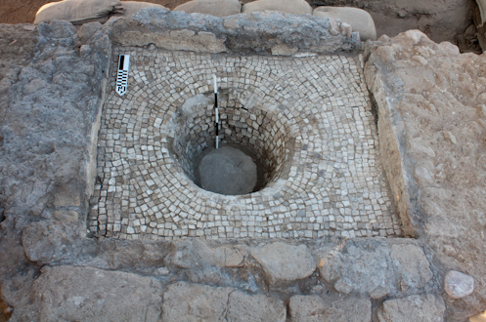

Fig. 7 Tiled wine vat 74.U264, and southern edge of 74.U308 (ashlars). View to south.

Portions of the shell platform 74.U233, a Fatimid construction which put the vat out of use, had likely functioned with this vat as an adjacent treading floor (See Fig. 8, next page), with its edges defined by the ashlar pier 74.U308 on the south, and similar ashlar edges on the northern and eastern edges. The rough outline of what may be an ashlar-edged treading platform is visible in the 2010 overhead photo taken at the season’s end (marked in red); the vat was uncovered beneath the area marked in blue:

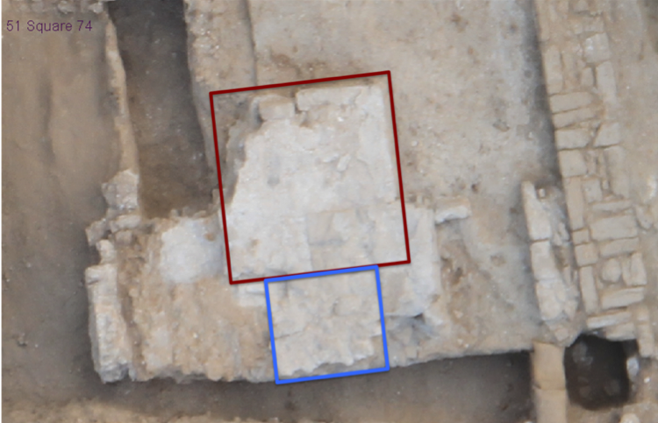

Fig. 8 Platform 74 U233, reused in a Fatimid building, seen from above (view to N)

When pressing was complete, open-air presses were said to have been washed out using salt and water, then covered over until the next year’s pressing season. (Sari Molhem 1997:199). This may explain why the sump and the areas of the vat had been filled up with clean beach sand (shells and all). The rough character of this fill would have served both to scour the spaces between tiles while also being relatively sterile and easy to remove. After the completion of the brief pressing season between June and September, the inhabitants likely cleaned and covered the installation with the intention of reusing it in the following year, but the building went out of use before that time. The layer of leveling fill which separated the vat from the shell concrete platform U233 constructed over it was set directly on top of this sand. (While this practice is typically documented for uncovered structures, it seems reasonable to assume that it might equally be a practice in a household or state level of production where the space might have served more than one purpose.)
The appearance of this Byzantine wine vat has brought clarity to a room 74.F.25 excavated in 1998-2000 in Square 74 and which has merited much speculation in the intervening years. It was excavated in separate pieces over the course of three separate seasons (1998-2000), and was therefore poorly understood in each of them. Initially dubbed an Islamic lime “kiln” in 1999, 74.25 was discovered upon later inspection of the pottery, to be a Byzantine installation cut down into Hellenistic rooms. In 2010 noted certain features of its construction, including a plastered (industrial) floor and suggested a possible association with the later bathhouse, either as a pool or an area for burning. The reconsideration of both the ceramic and the architectural evidence, particularly in light of the appearance of the nearby wine vat, and the existence of some parallel constructions at nearby sites has narrowed these possibilities.
In revisiting the excavation notes for each of the three seasons of its excavations, we can reconstruct the installation of 74.F25 as having three functional parts:

(1) An upper area of ca. 1.5 square meters in the east, defined by the ashlar blocks of 74.F225, 226, and 227. This area was paved with cobbles (74.F105=74.F224) and may well have had paved marble flooring above these well, from the single residual piece visible in the 74 lower East Section at this elevation. The lowest elevation of this part of the installation was at 18.85m, although it is clear that we have only the lowest portions of it preserved and its floor may have been even higher.

(2) A lower basin (the original “kiln” room), the base of which was supported with multiple rows of cobbles, paved with marble tile fragments, and then coated with plaster, at an elevation of 18.45m. This was connected to the higher eastern section by a square “spout” of sorts, constructed by placing two rectangular tiles of marble upright between an upper and lower ashlar. The “spout” showed signs of plastering inside. (Fig. 9)

(3) A sunken “sump”, similarly tiled with marble fragments and plastered, the base of which sat at just over 18.0m. (Fig. 10)

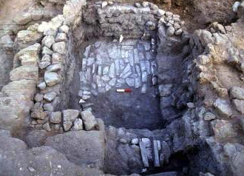

Fig 9. Sunken basin 74.F25 (Photo # 99-12156. view to W)
Note plastered “spout” in foreground, and the drop from the upper area into the basin.

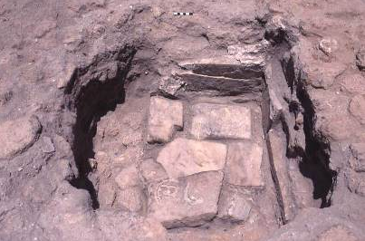

Fig. 10 Marble tiled sump (F119) in sunken basin 74.F.25 (Photo 00-12931, to N). The tile is incised with a decorative pattern, and is therefore clearly in secondary use.

Botanical evidence recovered from both the 1997-2000 and 2011 seasons suggests olive oil, in that all botanicals recovered were uniformly olive pits. And indeed, household production of wine and olive oil is apparently common in rural Byzantine estates. We lack, however, the large pressing stones or counterweights typical of olive-pressing installations, which may strengthen the case for wine production.
The date of the tiled vat itself is suggested both by stylistic parallels from east of the site, as well as by the appearance of Byzantine pottery within the backfill of the vat itself. The marble flooring of basin room, 74.U98, was covered by two layers of plaster separated by a shallow layer of fill (presumably indicating a replastering of the space) from which Byzantine pottery was discovered. Note however, that the majority of the pottery associated with this installation falls within the Late Hellenistic to Early Roman horizon, and that the Byzantine pottery recovered from it comes primarily from the reuse of the facility or or the actions which put it out of use. As such its original construction may have been earlier. All similarly constructed parallels in the Ashkelon region appear to be Late Byzantine, however.
Wines from the region of Ashkelon and Gaza were famous in the Byzantine period, and were enjoyed as far as Western Europe, renowned for their quality and even their medicinal efficacy (Johnson 2008). Excavation and surveys to the north and east of the city have uncovered evidence for the industrial scale production of wine and olive oil during this time, and also for the nearby production of the famous Ashkelonian and Gazan store jars in which these vintages crossed the Mediterranean. Yet despite the association between the city of Ashkelon and its famous wines, no wine presses of the Roman and Byzantine era had been discovered at the site itself. This wine vat is the first evidence we have for wine production within the city of Ashkelon itself during this era. It is not industrial in scale, however, and it seems more likely that this production facility belonged to a private household or estate. The finds on the associated Phase II floors to the south of this room excavated this season, and the reports of jewelry discussed in the 1998 in the NE rooms dating to this period may confirm the original interpretation of this building as a Byzantine “villa”.
One creative estimate suggests that 2.5 acres of planted vines are required to yield 100 L (26 gallons) of wine, depending upon the quality of the wine. Even in its current state of preservation, 74.U264 was capable of holding up to 2,472 liters (if filled to its currently preserved brim), which by this estimate would require in excess of 60 acres to fill it. It may be significant that in Grid 50, just east and downhill from the villa, Phases I and II were characterized by rows of “tree pits”. Originally identified as a scenic park or windbreak for houses higher up the hill, perhaps this might be better interpreted as the remains of a private olive grove or stakes for viticulture. The villa need not have had to produce all of its own crop, however. In many rural estates, inhabitants of the surrounding countryside would bring their produce to a central/common installation for pressing. Perhaps this wealthy household could have served as a central pressing place for nearby vineyards as well.
The vat and treading platform were covered over with cobbles and shell concrete during the subsequent use of the space as an Islamic bathhouse in Phase IB. Fill layer 74.U?? was set down over the top, between the sand backfill of the vat and the shell concrete 74.U233 which was set down above it, poured over the cobbles and ashlars 74.U308, etc.which functioned with the vat, incorporating them into one large platform. Portions of this platform, and the floor which sat some 30cm lower, were tiled with ceramic tiles, forming a subfloor chamber in this room (documented in the 2010 Grid Report). This clearly marks a change in the use of space, and an end to wine production during the Islamic period.

Phase IB (Early Fatimid-Crusader): The Bathhouse Returns
The bathhouse/tiled building discussed thoroughly in the 2010 Grid report was removed this season. The density of the concrete, both the shell concrete used in the construction of the walls and to line some of the floors, and the non-shell concrete which supported other identical tile floors, required the use of a jackhammer. It was during the removal of one of the chunks concrete platform/bedding for ceramic tiles of the bathhouse (85.U7) that the concrete split open to reveal yellow glazed Crusader scraffiato pottery and Fatimid purple-glazed cooking pot fragments embedded within the concrete itself. While our fundamental understanding of the building and its use has not changed, the late pottery would appear to push the tile-floor building out of the late Byzantine period and into the late Islamic Fatimid-Crusader period of the 10-12th centuries A.D. The reuse of the Phase II plaster-lined basin room 74.F25, marked by the laying of a shallow fill and resealing of the basin with a new coat of plaster 74.F84 probably also belongs to this phase, marking the reshaping of the earlier installations to suit the new function of the building.
Some uncertainties regarding this attribution should be acknowledged. The disparate remaining portions of the concrete building were not connected, their relationships severed by the dramatic robbing activity which brought this phase to an end (even to the extent of removing whole floors of rooms). As such, we cannot conclusively connect the shell concrete walls and wall stubs (83.F5, 73.F9-74.F20, 74.F19) directly to the patch of concrete in which the Fatimid pottery was found. This process is rendered even more difficult by the fact that many remains of this building, including whole chunks of concrete with tile still attached, had clearly been upended and toppled into the robber trenches as backfill. It is possible that the shell concrete walls and tiling could have functioned as an original use of the building in the late Byzantine/early Umayyad (the latest pottery from other portions of this building being no later than this), and that a rebuild which included the laying of new concrete floor was concluded in the Crusader period. The expansion of Grid 51 an additional 5m to the south should expose more of the remains of this building and perhaps shed light on this question in 2012.

Phase IA: The Pillaging of Grid 51
The tiled building was dramatically robbed shortly afterwards during the subsequent Crusader period, as were many of the walls belonging to the later phases of the insula. So significant is the robbing activity that in many respects we know these later phases only in their negative imprint: as floors without walls. Given our new understanding of the Phase IA shell and concrete building, the numerous robber trenches discussed in the 2008-2010 reports should be reassigned to this latest subphase of the Islamic period.
One striking feature of these Phase IA robber trenches was that the vast majority of the Fatimid-Crusader pottery recovered from them was quite fresh. Cooking pots were little, if at all used, and many seemed nearly brand new from their fabric. Glazed wares were not only abundant but their coloration seems to have been unusually well-preserved, perhaps suggesting only a short period of use. In fact, the pottery represented appears to fit quite neatly within the window of ca. 1150-1185 A.D.. This suggests that the robbing may have occurred after a sharp break of some kind – perhaps immediately after the arrival of the Crusaders, or after Salahadin’s destruction of the city.

A Note on Hamra Soil
A recurring feature in Grid 51 is the use of a variant of hamra soil as a lining, applied/smeared while wet like a plaster onto surfaces or the interior of various insulations. Striations of hamra clay of varying thickness are visible among floor laminations throughout the Grid from the Persian period through the Byzantine period. This same clay was used as a lining for the Phase IV mudbrick bin/installations in Building 2 (discussed 2010), and similarly lined the interior of a small Byzantine drain, above a layer of shell concrete.
According to soil specialist M. Toffolo from the Weizmann institute, this variant of hamra clay is not local to Ashkelon, being more reddish in coloration than the local brown hamra soil, but was likely brought in from Nizanim, some 15 km away. The heavier concentration of clay particles in this type of soil seems to make it less permeable to moisture, making it a good choice for surface treament – especially when dealing with liquids - or apparently as insulation in heating installations. The reddish color of the hamra, however, very much resembles the coloration of mudbrick or regular soil that has been exposed to heat. In 2010, hamra soils which had been used to line the bins Building 2 were sampled extensively, and renewed samples were taken in 2011. Visual inspection would suggest that these soils were burnt. However, the first spectra returned on the 2010 samples indicated that they either had not been burnt, or that they had only been exposed to temperatures below 350-440 degrees C - the heat produced by an average cooking fire or oven. This season it was determined, given the non-local nature of these soils, that a new baseline should be established specifically for this reddish variant of hamra soil, because the divergence in its mineral composition with respect to the local brown hamra might cause a different response to heat. We await the results of the new study, and hope to apply the results to better understand industrial and construction techniques throughout the Grid.

2012 Goals
Plans to expand the grid an additional 15 x 5 meters to the south were forestalled in 2011 by a limited number of volunteers, but the new cut will be made immediately prior to the 2012 season. This expansion will allow us to expose the southern edge of Building One, and allow for safer excavation to the depths necessary to reach the promising Iron I material glimpsed in the 74 probe. Next season will focus on bringing the upper areas of the Grid through Phases V and VI, down to the level of the Persian mudbrick-floored building in as many rooms of Building 1 as possible.

Thanks are due to directors Larry Stager and Daniel Master for the continuing opportunity to participate in the new phase of the Ashkelon Expedition.

The stone wall/bin 74.U376 was cut into the subfloor fill, and was not associated with the first horizon 74.U322.
The architectural function of 74.U318 and 74.U372 is not yet well understood . Perhaps functioning as a wall (74.U318) and an adjacent bench (74.U372), stepped down some 40cm below the preserved height of 74.318, both are built with sizeable stones and create a ca. 110 degree angle with the abutting wall 74.301=302.
Some uncertainty had remained regarding the southern closing wall of the southernmost row of rooms, it being unclear whether the rooms appearing in Squares 83 and 84 were part of the original Building 1, or represented a new building to the south. (See 2010 Grid Report, Fig. 2).
NC: 74.L171, NE: 74.L191, SE: 74.182, SW: 73.L235, NW: 73.L100
The N-S wall 75.U39 consists of two parts: a southern edge with stacked ashlar doorjamb, deeply founded and not yet floated, and a northern edge 75.U39, founded at a higher elevation on top of street material 75.U78. Without floating the wall it will not be possible to discern the join and dissociate these two features. It should be noted that the sequence in this area is complicated. The northern part of the wall was robbed out by Byzantine and Islamic robber trenches 75.U31 and 75.U46/7, respectively said to have been completed in 2010. At the beginning of 2011, the compact nature of the material above the stones of 75.U39 underneath these trenches was felt to be too compact to be robber trench, and were classified as street on the basis of texture. However, it is impossible that street at this elevation could have washed through the standing wall associated with the bins at the same elevation on the other side of the wall. It seems more likely that the ca. 5cm of material that remained covering wall 75.U39 should be identified as part of the later trench material. The alternative is that the standing wall U39 was robbed out at the end of Phase IV, and that Phase III street material (75.U43) built up over it.
S. Sari and E. Molhem, “The Technique and Mechanism of the Wine Press at Sa’ad”. Dirastat 24/1: 196-211. as cited in L. Khalil and F. Mayyada al-Nammari, “Two Large Wine Presses at Khirbet Yajuz, Jordan” BASOR 318 (2000): 41-57.
MC # 53028 (from74.F98,marble flooring); MC#s 52483, 52474, 52475, 52027, 52321 (from 74.L85, fill above the marble flooring); MC#s 53716, 53783, 53992, 53867 (from 74.F119, the marble-tiled sump). The above were recovered in 1999-2000. To these we add MC # 63659, olive pits recovered from (74.U244, the ashy matrix surrounding the cobbles (74.F105) which might have supported a platform. We await the phytolith results from sediment samples #541 and #542 (2011) taken from those layers as well.
Y. Huster, pers. comm..
See summary of sites in Johnson and Stager (2008):481-2.
Rautman, Daily Life in the Byzantine Empire 2006: 181.
M. Heltzer, “Olive oil and wine production in Phoenicia and in the Mediterranean trade” in M. Amouretti and J-P. Brun (eds.) La Production de vin et d l’huile en Méditerranée. (Athens 1993): 49-54;
The chain of connection, such as it is, runs as follows: Concrete pier 84.F5 was covered by shell plaster subflooring. Identical subflooring ran underneath the ceramic tile flooring of 84.U??. Concrete non-shell subflooring was uncovered at an identical elevation slightly further to the east, and the concrete patch from which the Fatimid pottery was recovered lay within a robber trench (at an euivalent elevation), with ceramic tiles identical to 84.U38 attached above it.

